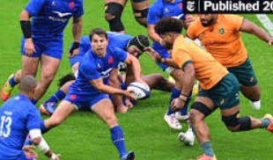
PE
Sending and Receiving
Computing
Throughout this half term, we will be learning about communication.

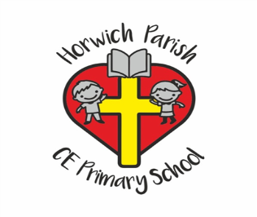
Year 5
Spring 1
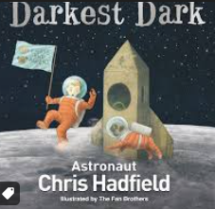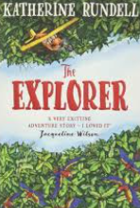
English
In English we will be reading ‘The Darkest Dark’ and writing a biography.
In reading skills, we will be using the novel ‘Explorer’ to practise daily reading skills.
Science
We will be studying ‘Life cycles and reproduction’
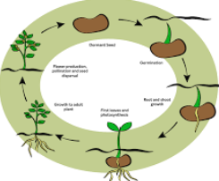
RE
We will be learning about Judaism and why the Torah is significant.
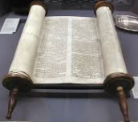
PSHE
We will be learning about economic wellbeing.

Music
In music, we will be studying composition to represent the festival of colour.
Art
In art, we will be completing a drawing unit called ‘I need space’
History
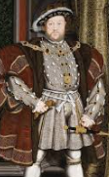
As historians, we will be studying the Tudor period.
Maths 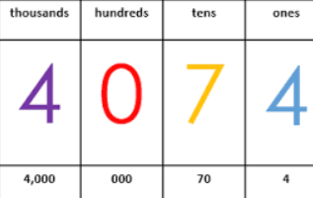
Multiplication and Division
Fractions
Decimals and Percentages
Perimeter and Area
Statistics

