RE
Why is the Torah so important to Jewish people?
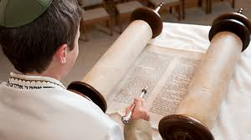

Music
Songs of World War 2
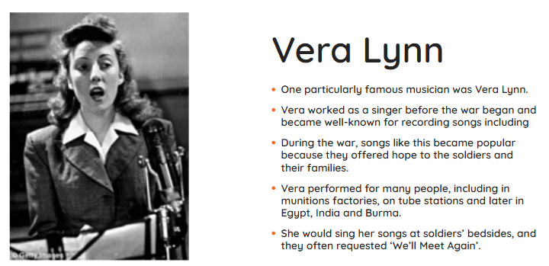

Maths
Fractions, decimals, percentages
Area and perimeter
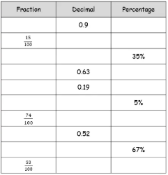

Science
Circuits, batteries and switches
English
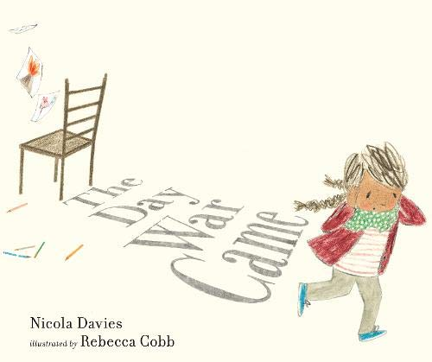
Write a letter and a diary entry linked to refugees and evacuees

History
What was the impact of World War 2 on the people of Britain?
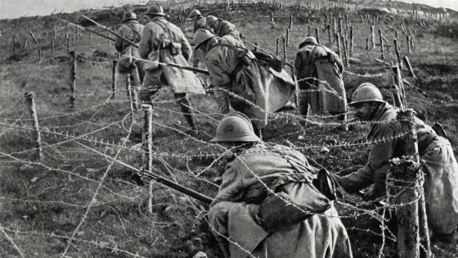

PE
Dance – Into the Woods


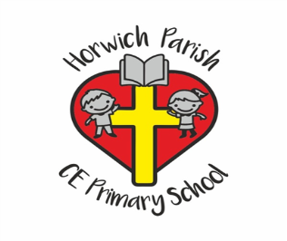
Year 6
Spring 2 2026

Computing
Data Handling
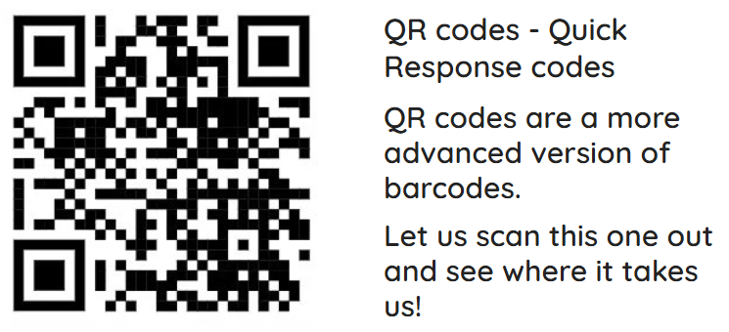

Art and Design
Painiting and mixed media artist study


PSHE
Citizenship


