Maths 
Fractions and Decimals and
Children will learn how to:
- Partitioning mixed numbers
- Adding and subtracting fractions
- To find fractions of amounts.
- Understand the whole

History / Geography 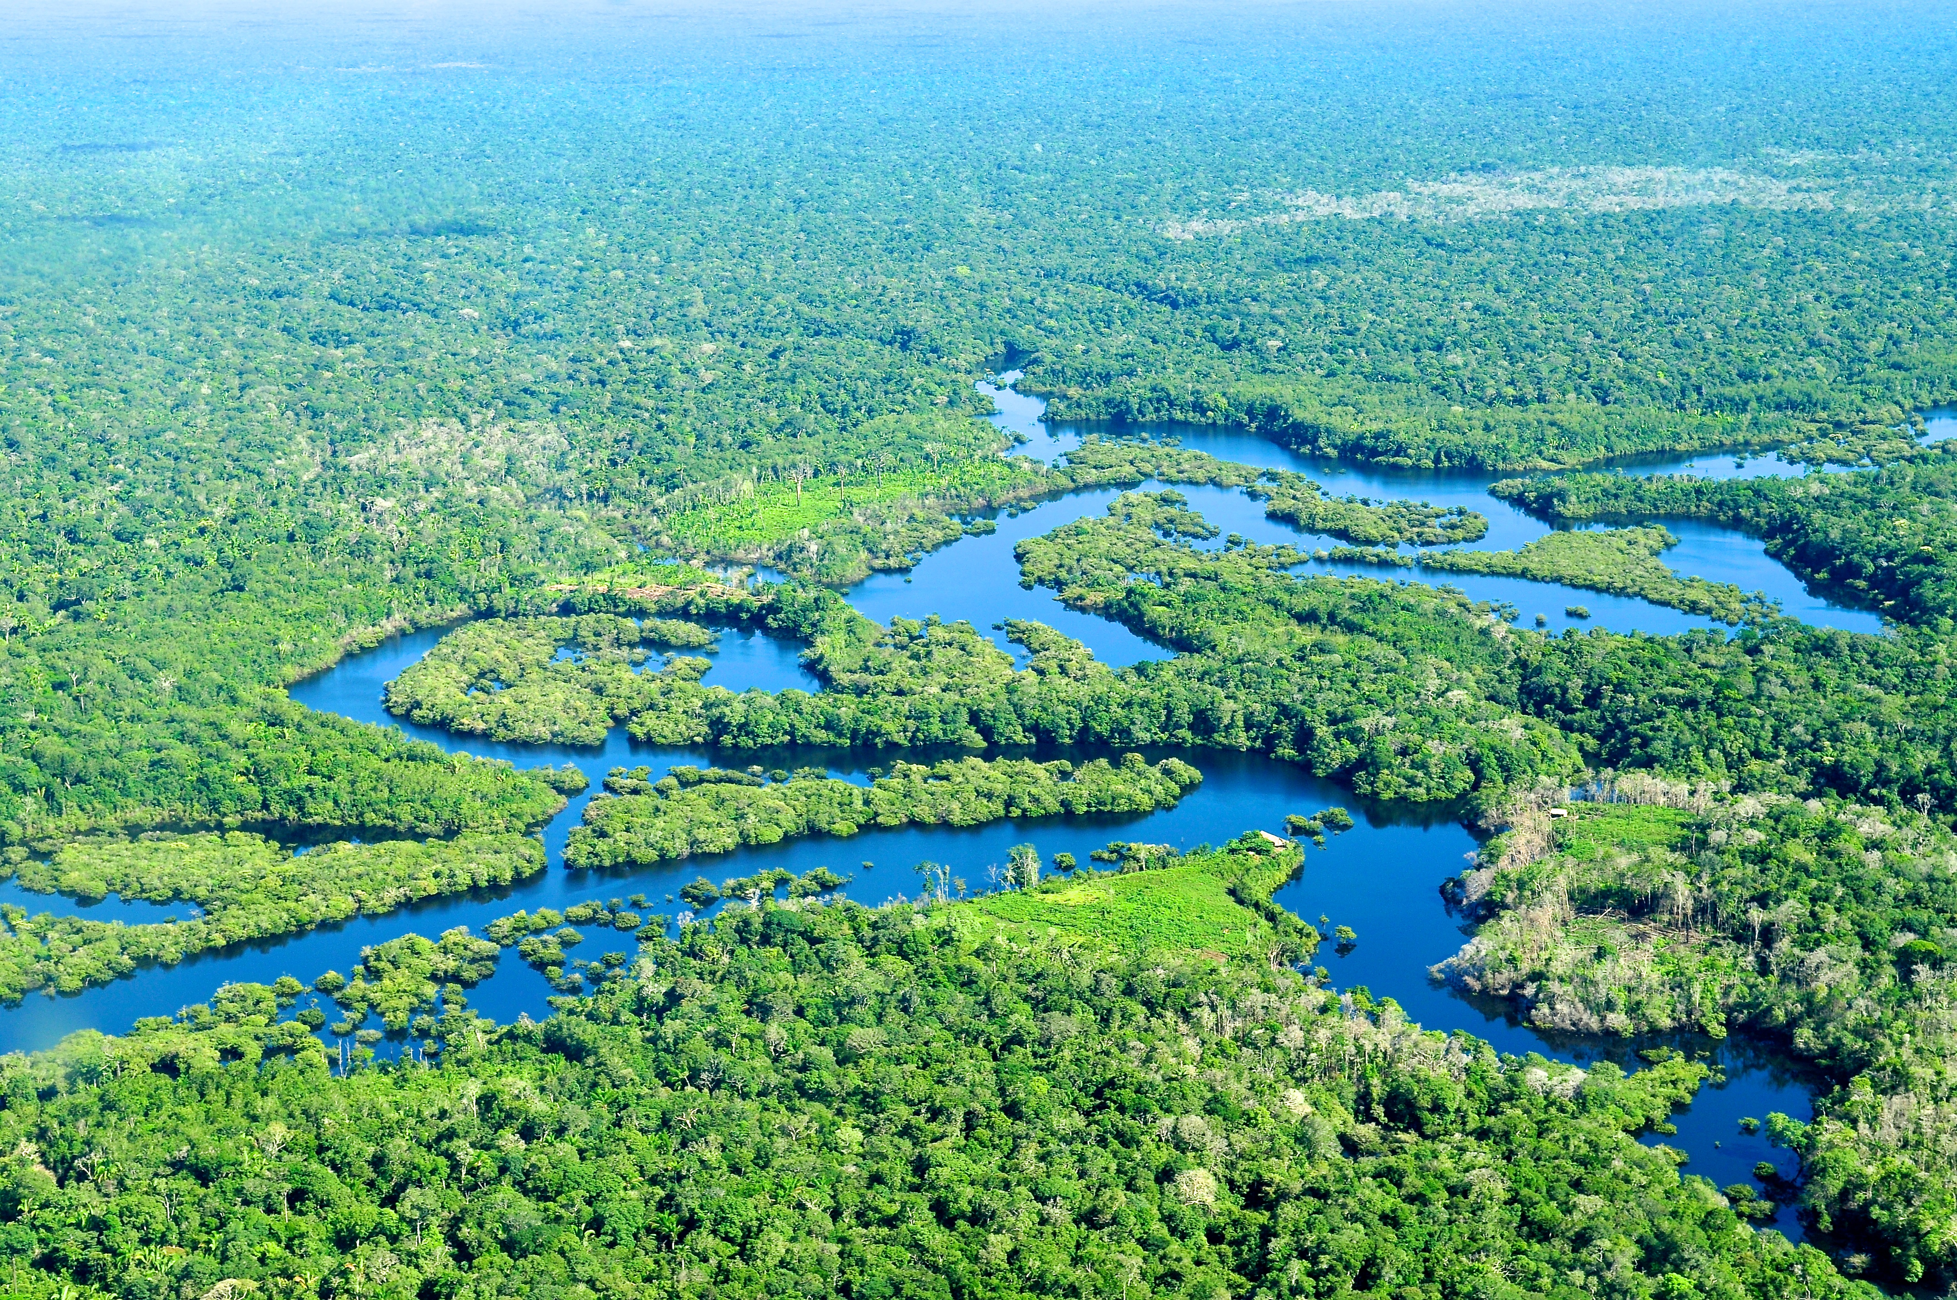
This term we will be focusing on History – How have children’s lives changed?
We will be learning:
- What children’s lives were like in Tudor times
- What children’s lives were like in Victorian times
- Who Lord Shaftsbury was
English 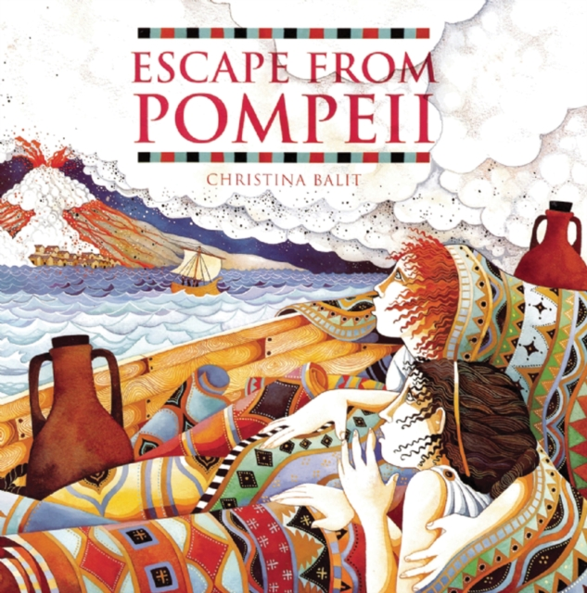
This term we will be reading ‘Koji’s Island’ and ‘Amazing Islands’ by Sabrina Weiss
The children will write a story from a point of view of a character.
Science 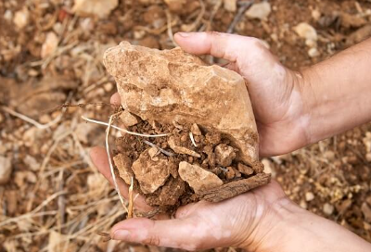
We are going to be learning about Animals including Humans: Digestion and Food
The children will learn about:
- How the human digestive system works
- What our different teeth are used for

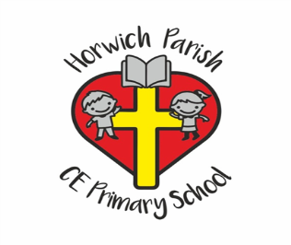
4/5H
Spring two
PE 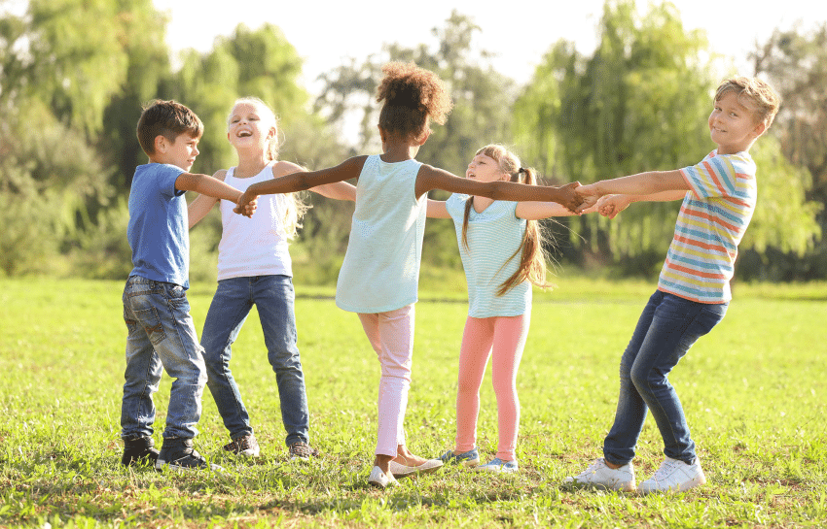
This term we will be focusing on:
- Sending and Receiving
- Attacking and Defending.

RE 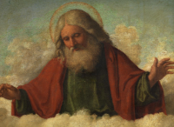
How do festivals and worship show what matters to a Muslim?
We will be learning about:
How Muslims celebrate Ramadan and why the mosque is important to Muslims
Music 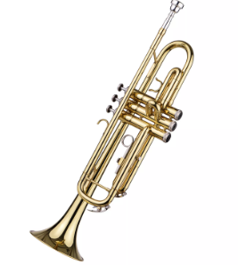
We will be learning about: Body and tuned percussion (rainforests)
Art / DT 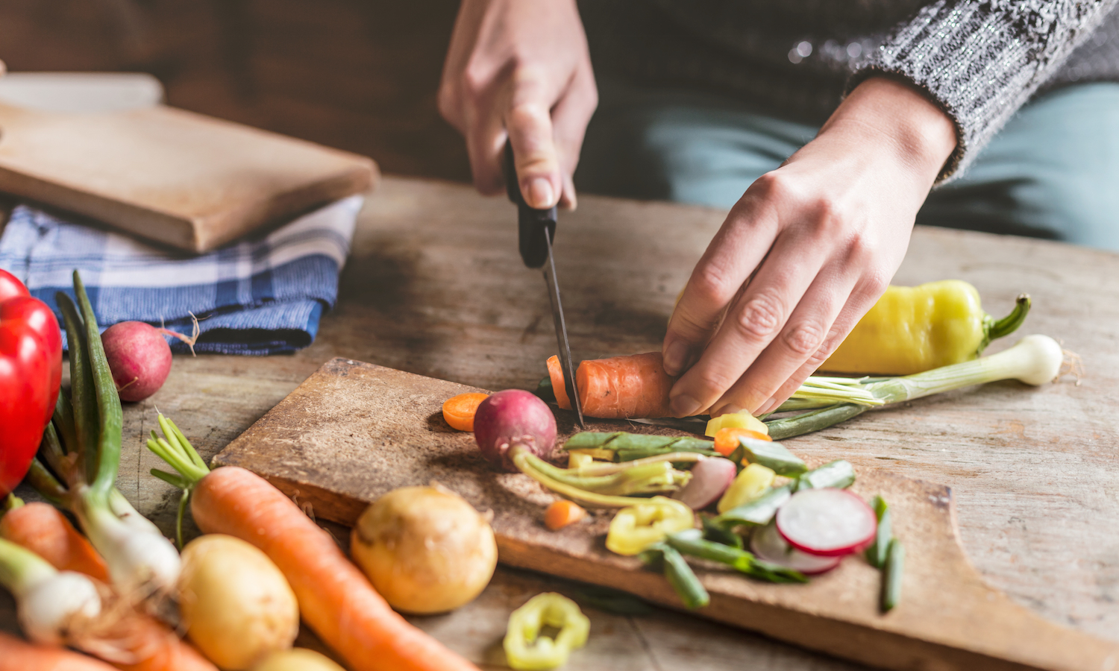
We are doing Art this term and we will be developing drawing skills
We will be:
- Developing shading skills
- Adding detail to drawings using line, tone and shape
PSHE 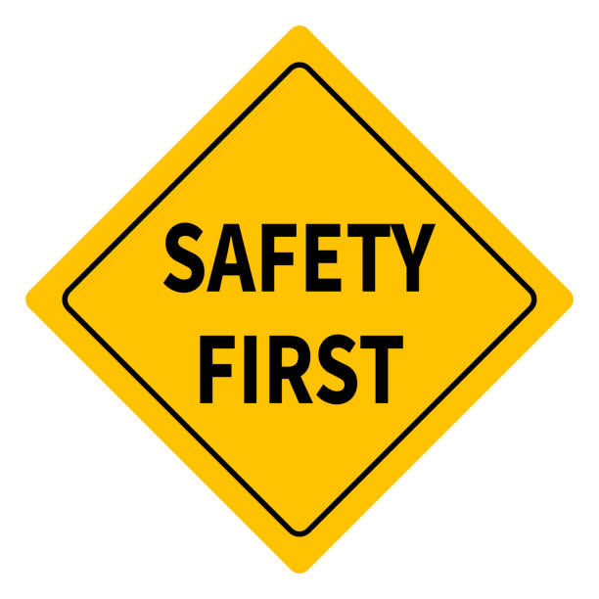
This term the children will be learning about Citizenship
We will be learning about:
- Our rights and responsibilities
- How we can protect the planet
- How we can contribute to the community
- How parliament works
Computing 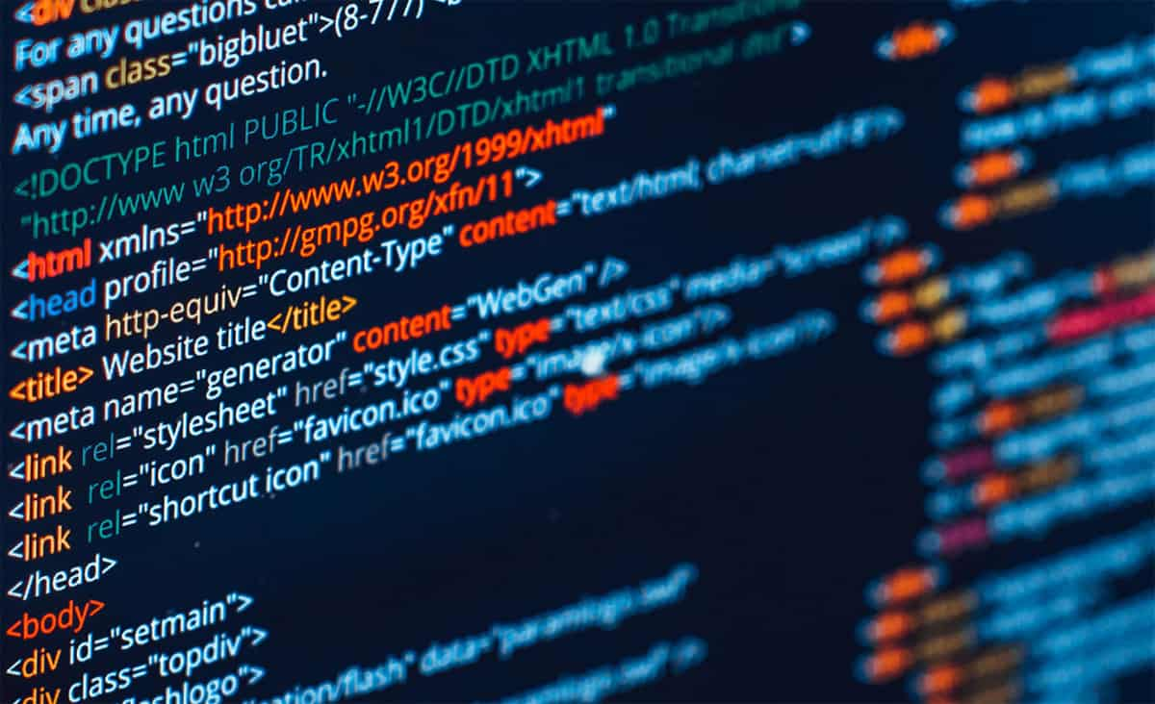
Computer Systems and Networks
We will be learning about:
- What a network is and how it works
- How websites work
- What a router is and how it works

