Science – Light and Shadows

We will be exploring the link between light and darkness, observing reflections and investigating different factors that affect shadows.
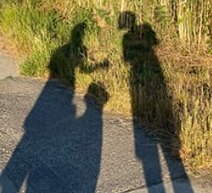

That affect shadows.
Maths – Fractions, Mass and Capacity
We will learn to:
- Understand and compare unit and non-unit fractions
- Count in fractions in a number line
- Measure in grams and Kilograms
- Measure in millilitres and litres
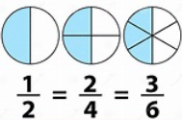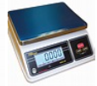

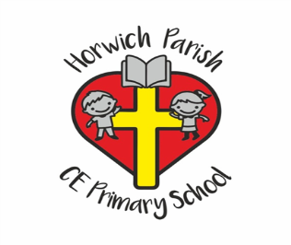
3B
Spring 2
History – Why did the Romans invade and settle in Britain?
We will be investigating why the Romans invaded, how the Celts reacted and how the Romans changed life in Britain.
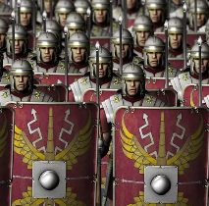

Music – Pentatonic Melodies

We will be learning about the music used to celebrate the Chinese New Year festival. We will be writing pentatonic melodies and performing as a group.
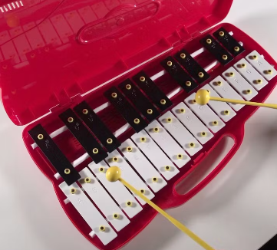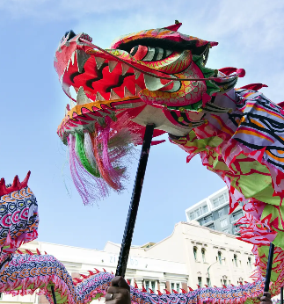

RE – How do festivals and family life show what matters to Jewish people?
We will be learning about Jewish worldviews and way of life. We will build up our understanding of festivals.
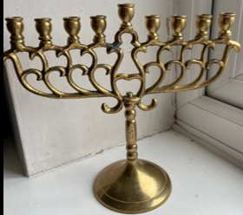
English – The Silence Seeker by Ben Morley
We will be writing a narrative of The Silence Seeker including details of the setting and some dialogue.
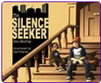

PE
Mondays – Attacking and defending
Thursdays – Dance


Computing – Systems and Networks: Emailing
We will be learning how to send emails with attachments and how to be a responsible digital citizen by thinking about the content of what we send.

PSHE – Citizenship
We will learn about:
- Children’s rights and rules
- Recycling
- Charity
- Local community groups and democracy


Art – Developing drawing skills

We will be developing shading skills and drawing techniques to create botanical-inspired drawings.




