English
We are going to be developing our grammatical skills; learning how to use suffixes and prefixes.
We will write a story in the first person.

Maths
In this half-term we will be focusing on three areas of mathematics: place value within 50, length and height and mass and volume.

Science
Comparing animals
In this topic we are going to think about the features of different animals.
We will be learning how to identify carnivores, herbivores and omnivores based on their diets.

History
Our topic this half-term is ‘How have toys changed?’
Within this topic we will be thinking about the evolution of toys over a span of 100 years.
We will also be making predictions about what toys might look like in the future.

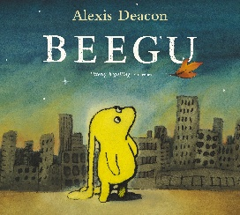
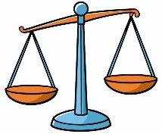

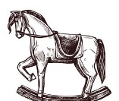
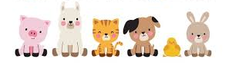

RE
We will be exploring the key question ‘Who do Christians think made the world?’
We will be using our knowledge of God and the creation story to answer deeper questions.

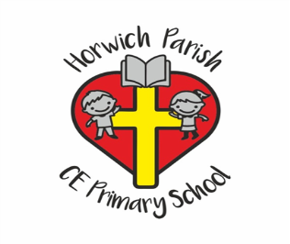
Year 1
Spring 2 2026

PE
Sending and Receiving

PSHE
Citizenship
In this unit we will explore what it means to belong, why we have rules, how we can care for others and the importance of democratic decisions.

Art
Woven wonders
We will be using different materials to experiment with weaving styles and techniques.

Music
Sound Patterns
We will be using the story of the Three Little Pigs to talk about rhythm.
We will be using percussion instruments to create our own sound patterns.

Computing
Data Handling
In this unit the children will learn how to find, input and analyse basic data.




