History / Geography 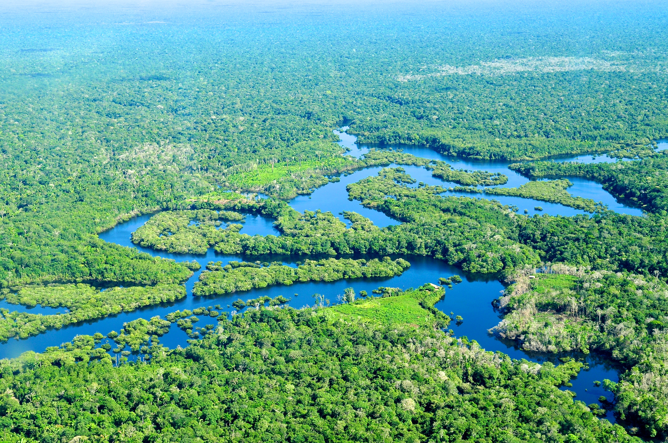
This term we will be focusing on Geography- Why are rainforests important to us?
We will be learning:
- Describing a biome and give an example.
- Stating the location and some key features of the Amazon rainforest.

Science 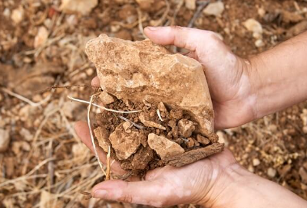
We are going to be learning about Rocks and Soil
The children will learn about:
- Defining the term rock.
- Describing the appearance of different rocks, identifying both crystals and grains.

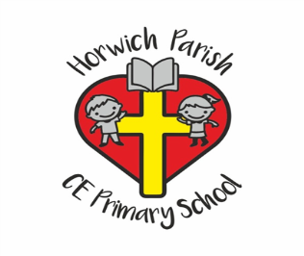
4/5H
Spring one
English 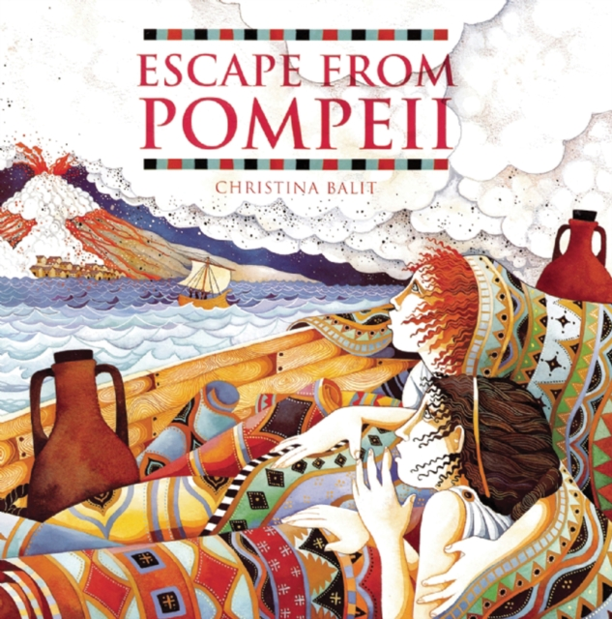
This term we will be reading Escape from Pompeii, the children will write a story some a point of view of a character.
PE 
This term we will be focusing on dance.

Maths 
Multiplication and length
Children will learn how to:
- Their times tables.
- Multiples and divisions for 3, 6, 9, 7, 11 and 12.
- Common factors
- Prime numbers

RE 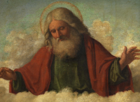
We will be learning about: What is it like for some to follow God?
We will be learning about:
God and the people who follow him, we will interview people from Church.
Computing 
Programing: scratch
We will be learning about:
- Identifying Scratch as a coding application and explore its different code blocks.
- Making predictions about what code blocks will do and test these ideas.

Art / DT 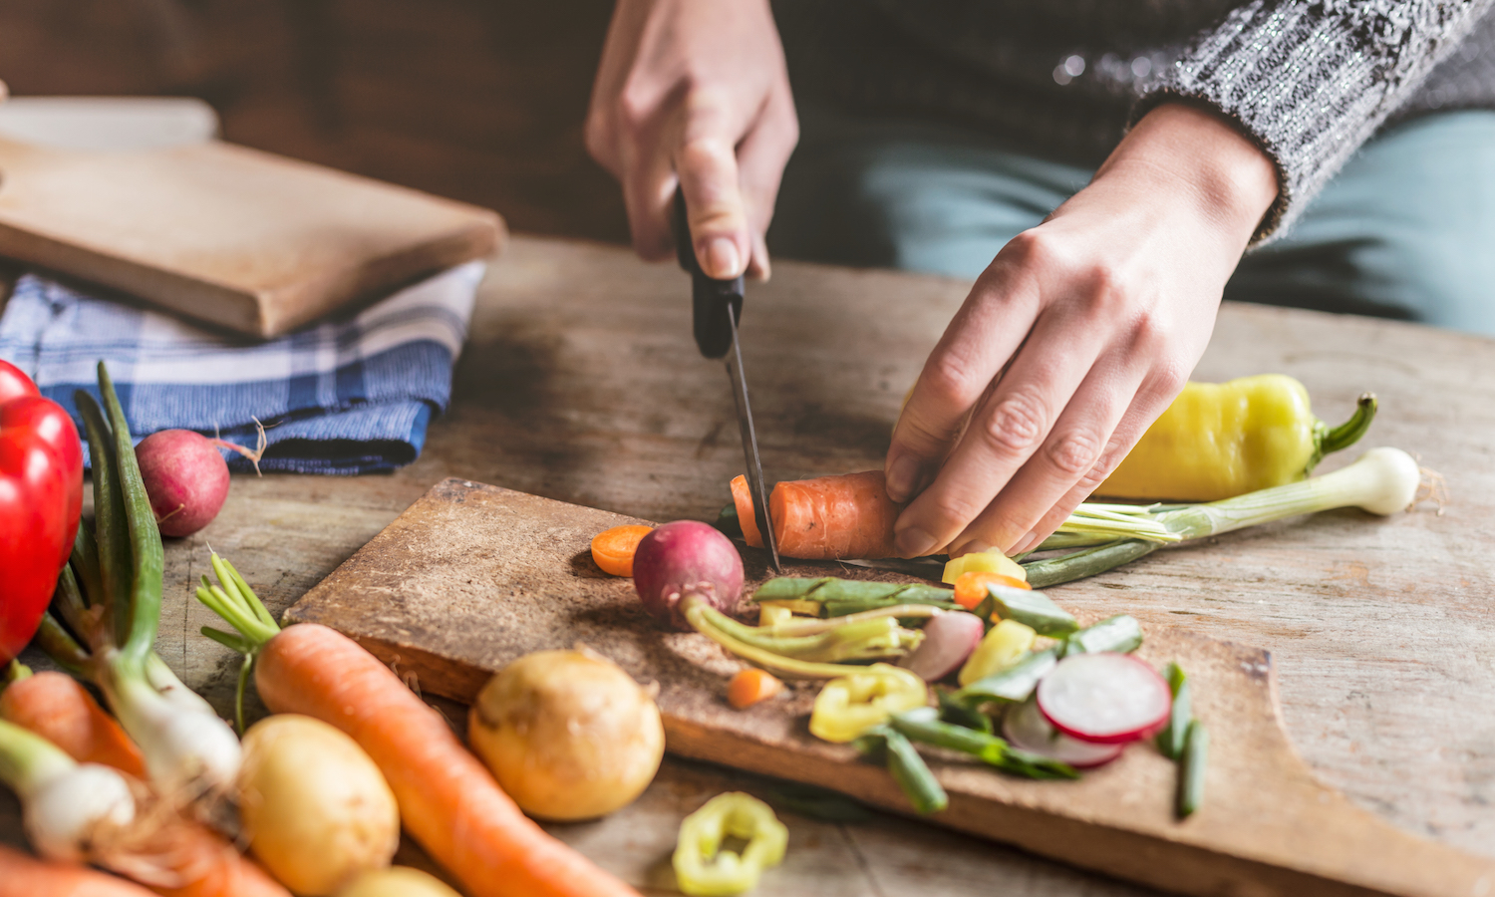
We are doing DT this term and we will be doing Cooking and nutrition: adapting a recipe
We will be:
- Describing features of biscuits using taste, texture and appearance.
- Explaining why some biscuits might be made for children, adults or special occasions.

PSHE 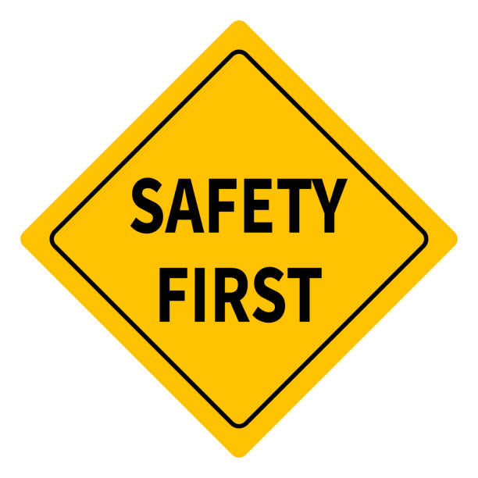
This term the children will be learning about Safety and the changing body.
We will be learning about:
- Understanding the reasons for legal age restrictions.
- Understanding how quickly information can spread on the internet and some of the risks associated with that
Music 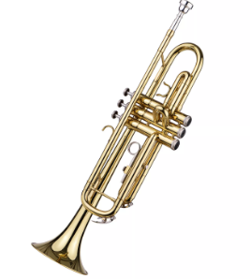
We will be continuing to take part in our Brass lessons.

