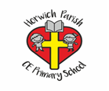

Adaptive Teaching Ideas for Music

- Visual aids eg. Musical notes and number of beats.
- Visual representation of an octave.
- Vocab mats / displays with definitions of vocabulary.
- Use of progression ladders to see the skills that come before / after.
- Actions to support recall of vocabulary.
- Pre-teach vocabulary.
- Retrieval activities of vocabulary.
- Repeat and practice playing instructions.
- Clap / sing before playing.
- Limit/ extend time spent on a task.
- Change instruments used.

