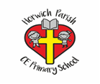

Adaptive Teaching Ideas for Geography

- Rhymes / poems to help retain information.
- Partially completed labels.
- Different / simpler maps.
- Sentence stems.
- Visual prompts.
- Use of digital resources eg. Google maps / Digimaps.
- Additional instructions.
- Modelling of tasks.

Field Trip Adaptations
- Small groups
- 1 to 1 adult support
- Simplified map / table
- Large print.
- Visual resources.
- Pre-teach to prepare for trip.

