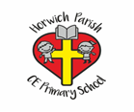

Adaptive Teaching Ideas for DT

- Digital / visual tools.
- Different resources eg. Scissors
- Visual prompts.
- Modelling and demonstrations.
- Allowing breaks.
- Giving more time to complete tasks.
- Peer / adult support.
- Link to real-life experiences.
- Pre-teach vocabulary.
- Less to complete (eg. partially cut out resources).
- Resources to assist recording (eg. Pictures, shapes to draw around).
- Larger / smaller scale resources.

