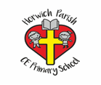

Adaptive Teaching Ideas for Art

- Adaptations to equipment – thicker paint brushes, larger paper, blu-tack book or paper so it doesn’t move.
- Vocab mats.
- Chunk tasks
- Repeat instructions.
- Visual instructions.
- Model instructions.
- Simplify tasks eg. to require less cutting
- Allow longer to complete tasks.
- Fewer resources to work with.
- Scaffolded eg some guidelines
- Sentence stems for commenting on artwork.

