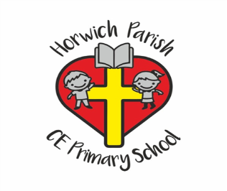
3B
Spring 1
Geography – Who lives in Antarctica?
We will learn about the location, physical features and human features of Antarctica. We will plot Shackleton’s route to Antarctica and plan our own simple route around school on a map using compass points.
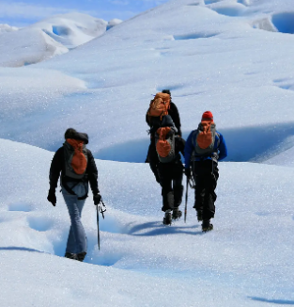

Music – Developing singing techniques (Theme: the Vikings)

We will be learning and singing a Viking song. We will use simple rhythmic notation to compose our own Viking battle song.
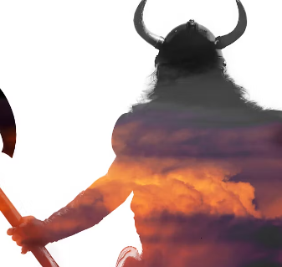

RE – How do festivals and family life show what matters to a Muslim?
We will be learning about the importance of prayer to Muslims, Ramadan, the mosque and the Qur’an.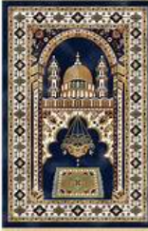

English – Stone Age Boy by Satoshi Kitamura
We will be building our writing skills to write a narrative (historical fiction) from the point of view of the boy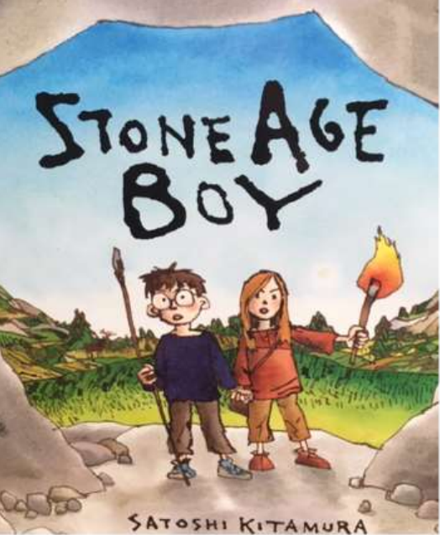

Maths – Multiplication & division, Length & Perimeter
We will learn to:
Multiply and divide 2-digit numbers by 1-digit numbers
Measure lengths in millimetres, centimetres and metres and convert between the units.
Measure and calculate perimeter.


PE
Mondays – Key PE coach
Thursdays – Dance


Computing – Programing Scratch
We will be exploring Scratch by programming an animation and improving it through testing and debugging.

PSHE – Safety
We will learn some first aid skills and how to help people. We will learn the importance of being kind online and road safety.
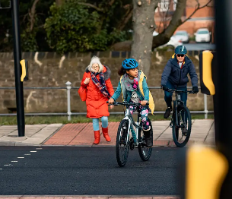

Science – Rocks and soil

We will be exploring the physical properties of rocks and soils and fossil formation.



DT – Cross stitch and applique
Textiles: Cushions

We will be learning how to use cross-stitch and applique when designing and making a cushion.



