PE 
Dance
Sending and Receiving
Computing
Throughout this half term, we will be studying programming.

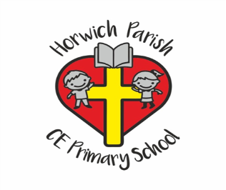
Year 5
Spring 1
English 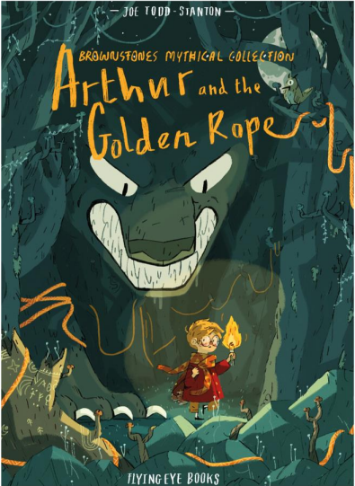
In writing skills, we will be following the myth ‘Arthur and the Golden Rope’ to write our own myths.
In Reading Skills, we will be developing our reading skills while reading ‘Cosmic’.
Science
We will be studying Space with a specific focus on our Solar System.
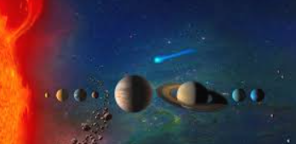
RE
We will what it means when Christians believe God is Holy and Loving.
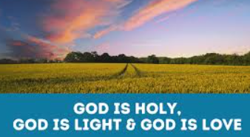
PSHE
We will be learning about Citizenship.

Music
We will be studying music from South and West Africa
DT
This half term we will be studying structures in bridges.
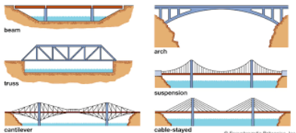
Geography

In Geography, we will be learning about the world’s oceans.
Maths 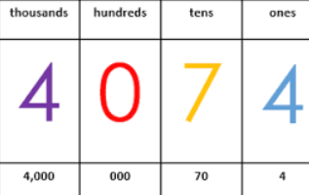
Multiplication and Division
Fractions
Decimals and Percentages
Perimeter and Area
Statistics

