RE
What does it mean if Christians believe God is holy and loving?


Music
Theme and variations
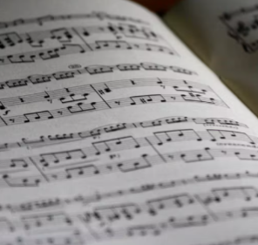

Maths
Ratio
Algebra

Design Technology
Textiles: stuffed toys


Science
Evolution and inheritance
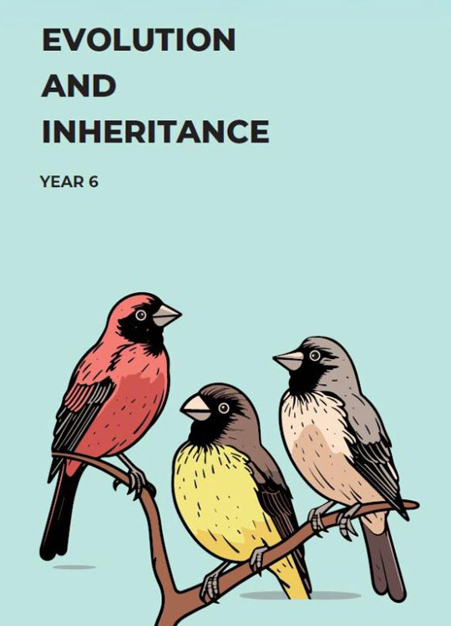

Computing
Programming
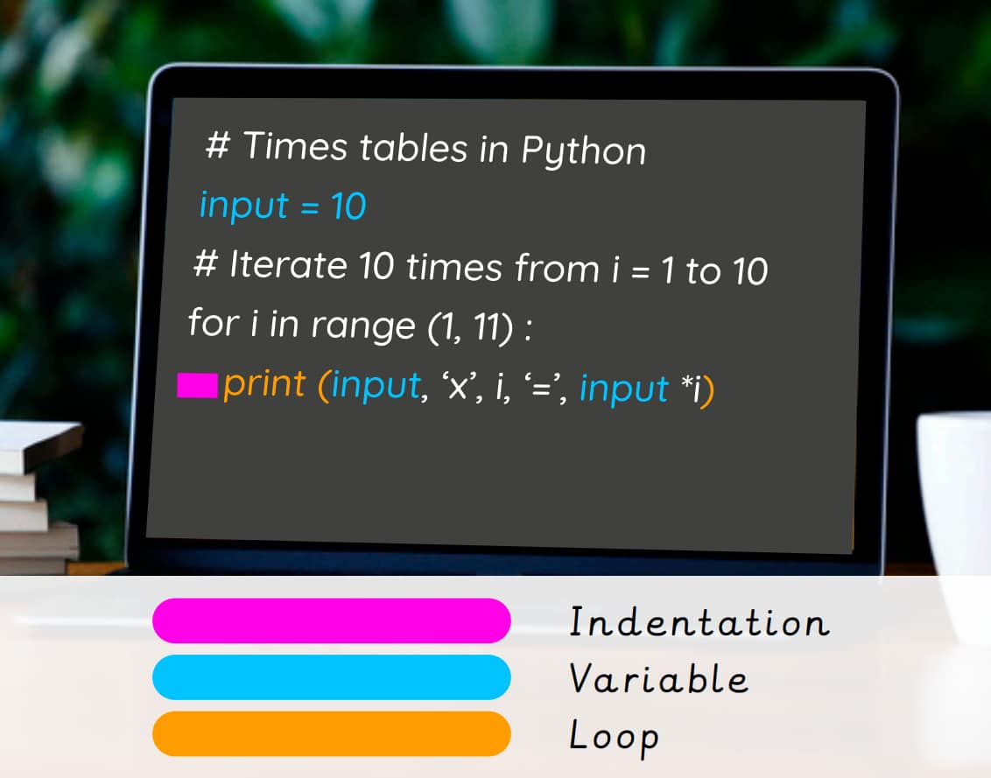

English
Writing a journal recounting Shackleton’s journey to the frozen north.
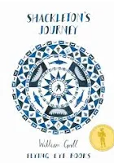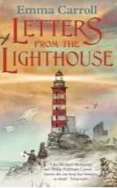
Reading Letters from the Lighthouse by Emma Carroll

Geography
Would you like to live in a desert?


PE
Dance – cowboys


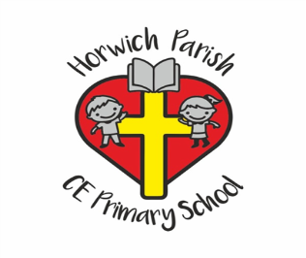
Year 6
Spring 1 2026

PSHE
Safety and first aid


