Science
We are going to be learning about Living things: Habitats.
We will be learning:
- To identify characteristics of living things.
- To recognise the difference between things that are alive, were once alive or have never been alive.
- To identify plants and animals in different habitats and how a habitat provides for them.
- To understand what a food chain is.
Computing
This term the children will be learning about Algorithms and debugging.
We will be learning:
- What an algorithm is and how to write our own.
- To understand what abstraction is.
- To understand what debugging is.
RE
We will be learning about: ‘What do Christians believe God is like?’
We will be learning:
- Parables are stories told by Jesus to teach his followers about God.
- The Parable of the Lost Son and how this teaches Christians that God is loving and forgiving.
- Jonah and the Big Fist- how Christians put their beliefs into practice through worship.

Music
This term the children will be learning folk songs and creating sounds to represent the seaside, countryside and the city.
We will be learning:
- To learn to sing a British folk song.
- To practise and perform a song relating to the countryside.
- To practice and perform a song relating to the city.
- To create symbols and represent sounds.
- To develop and perform a musical composition.

Art / DT
We are doing DT: Mechanisms: Making a moving story.
We will be learning:

PE
This term we will be focusing on Dance. We will be learning different ways of travelling, movements and balances and combine them in our own dance routines.

Maths
This term the children will be learning Money and Multiplication and Division.
We will be learning:
- Count money and choose notes or coins to make an amount.
- Compare amounts of money.
- To calculate and find change.
- To recognise, make and add equal groups using grouping and sharing.
- To use arrays.

History / Geography
This term we will be focusing on Geography- ‘Would you prefer to live in a hot/cold place?’
We will be learning:
- Where are the continents?
- Where are the coldest places on Earth?
- Where is the Equator?
- What is life like in a hot place?
- Do we live in a hot or cold place?
- Would you prefer to live in a hot or cold place?

PSHE
This term the children will be learning about Safety and the changing body.
We will be learning:
- How to stay safe when using the internet.
- To understand the difference between secrets and surprises.
- To understand the concept of privacy and correct vocabulary for body parts.
- To understand safe and unsafe touches.
- To know my body is important and belongs to me.
- To understand ways to keep safe on and near roads.
- To begin to understand how to stay safe with medicines.

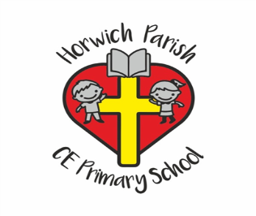
Year 2
Spring 1
English
The children will

