English
We are going to be developing our writing skills with a focus on story writing. We will be learning about the three parts of a story; beginning, middle and end and writing events in chronological order.


Maths
We will be learning all about 20. Key skills include: counting forwards and backwards, finding one more and one less and adding and subtracting within 20.

Science
Senses
In this topic we are going to explore the five senses in detail and make links between our sensory experience and the body parts that help us.

RE
Our topic is ‘What do Christians believe God is like?’ We will be exploring who God is to us and how other people see him in their lives.

Computing
Programming.
In this topic, children will understand what an ‘algorithm’ is and will have a go at using them to program BeeBots.

Geography:
Our topic this half-term is ‘What is the weather like in the UK?’
Within this topic we will be exploring how weather patterns link to the four seasons and how we can prepare for different types of weather.

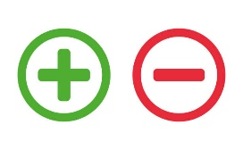
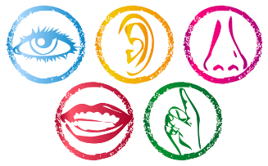
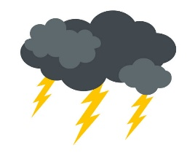

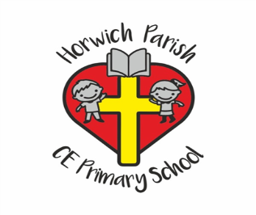
Year 1
Spring 1 2026

PE
Dance


PSHE
Safety
In this topic we will explore who keeps us safe, what being safe means and what to do if we don’t feel safe.

Design Technology
Making a moving storybook.

Music
Dynamics
In this topic we will be learning how to make loud and quiet sounds with a seaside theme.

