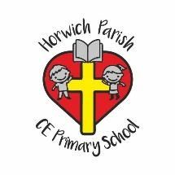
SMSC Subject Statements

Subject: PSHE
Spiritual
- PSHE supports spiritual development by encouraging children to explore beliefs and experience; respect faiths, explore feelings and values; and learning about their self- worth. We offer opportunities for children to explore and develop their creativity and a sense of awe and wonder of the world around them.

Moral
- PSHE supports moral development by exploring both Christian and British values. Through this, the children begin to recognise right and wrong; the importance of respecting the law; developing an understanding of consequences and engage in opportunities to investigate moral and ethical issues. We encourage every child to demonstrate our core values of love, respect and forgiveness in all aspects of school life.

Social
- PSHE supports social development by encouraging children to use a range of social skills; arranging opportunities to participate in the local community; developing an appreciation of diverse viewpoints; and developing the skills of participation, volunteering and cooperation; resolve conflict through Restorative Practice; and engaging with the 'British values' of democracy, the rule of law, liberty, respect and tolerance. Children are encouraged to take on roles and responsibilities within school and to ‘let their lights shine’ in extra- curricular activities.

Cultural
- PSHE supports cultural development by fostering understanding of cultural influences; encouraging an appreciation of the role of Britain’s parliamentary system; organizing participation in culture opportunities; and exploring further our understanding, acceptance, respect for and celebration of diversity. This will enable each child to develop a greater understanding of their own cultural identity.

