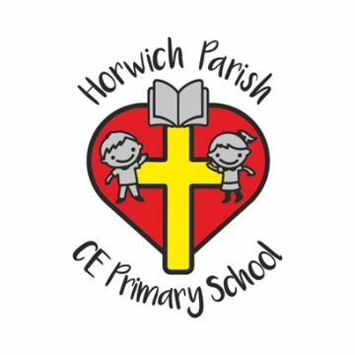
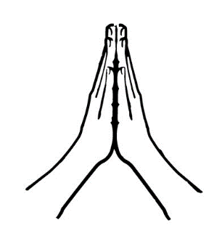
Tuesday 30th September
Be Still Day
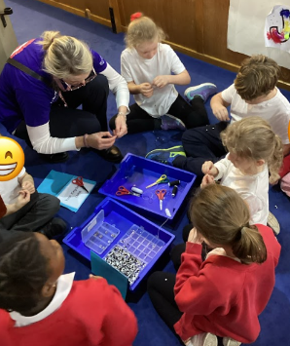
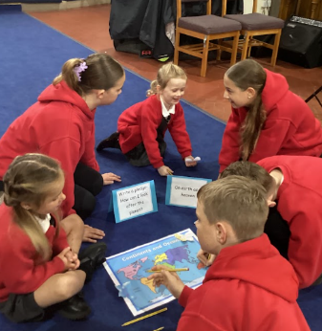
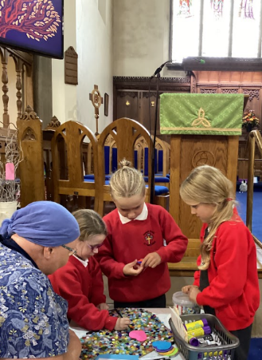
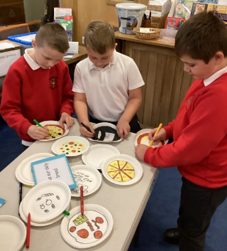
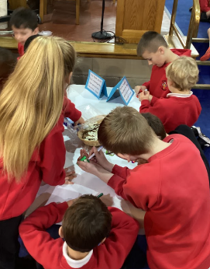
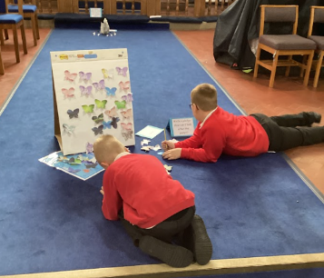
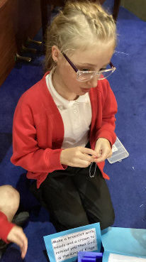
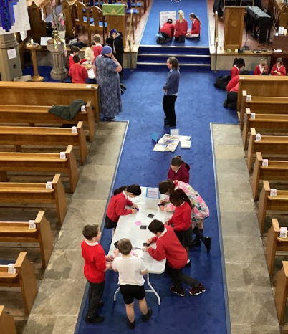
This year’s themed day was an opportunity to explore the Lord’s Prayer. Each class spent time in church completing a range of activities.
Station | ACTIVITY
Our Father in heaven | What does heaven look like?  Draw your image of heaven.
Hallowed by your Name | Create a design using your initial
Your kingdom come | Make a bracelet with beads  and a crownto remind you that God is King of Kings
On earth as in heaven | Write a pledge – how can we look after our planet
Forgive us our sins | Sorry prayers  Write I’m sorry on a piece of kitchen roll and place it in the bowl of water to watch the letters merge.
Lead us not into temptation | Can we make wise choices?  Read through scenarios – either/ or
For the kingdom, the power,  and the glory are yours now and for ever. | Say thank you to God, remembering how special He is.  Decorate a heart
Teaspoon prayers | Use teaspoons to spend time thinking about thank you, sorry and please prayers.
Bible station | Look at the selection of Bibles. Can you find your favourite Bible story?  Why is it your favourite?
Prayer corner | Post it notes, hearts, worship time prayers.

