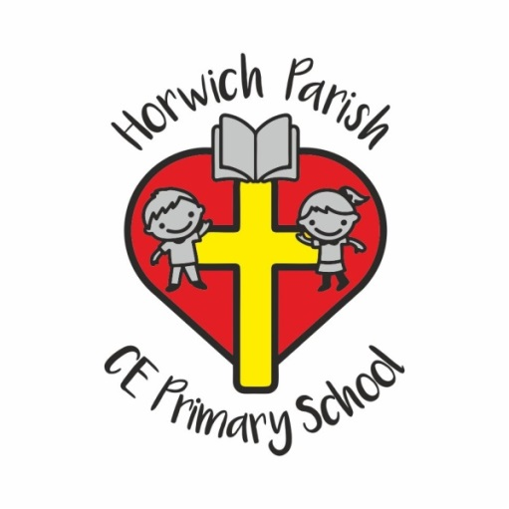

The Lighthouse Club at Horwich Parish CE Primary School

Password Form

Please complete and return this to the school office or via email - lighthouse@horwichparish.net as soon as possible.
The password provided will be required when collecting your child from the Lighthouse Club.
Reminder: Only named contacts on your registration form will be able to collect your child from our club.

PUPIL INFORMATION

Surname: |  | Forename:
Male/Female (delete as appropriate) |  | Date of Birth:
Primary Contact Name: |  | Home Telephone Number:
Password

PARENT/CARER INFORMATION – Parents should be informed that in the event their child is not collected from the setting by an authorised adult and no contact has been made with parents/carers within 45 minutes to 1 hour of the latest collection time (6pm), the school will follow their child protection procedures.

