Music – Creating compositions (Theme – Mountains)

We will be telling stories through music, creating a soundscape and adding story sound effects and a rhythm.


RE – What is the trinity and why is it important for Christians?
We will be learning about the baptism of Jesus and finding this in the Bible. We will investigate how Christians show their beliefs about God and the Trinity.
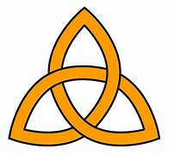

English – Nen and the Lonely Fisherman
We will be building our writing skills to write a fantasy story based in a classic tale, changing the setting. 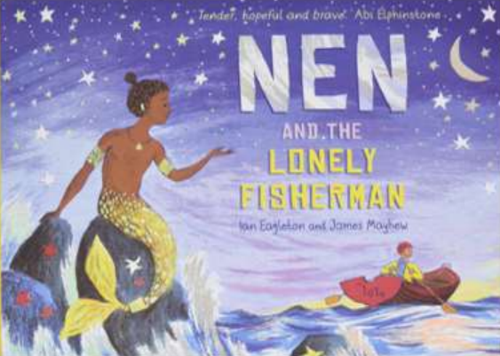

Maths – Multiplication & division
We will learn to:
Multiply and divide by 2,3,4,5,8 and 10 (Multiplication tables and corresponding division facts).
Multiply a 2-digit number by a 1-digit number.
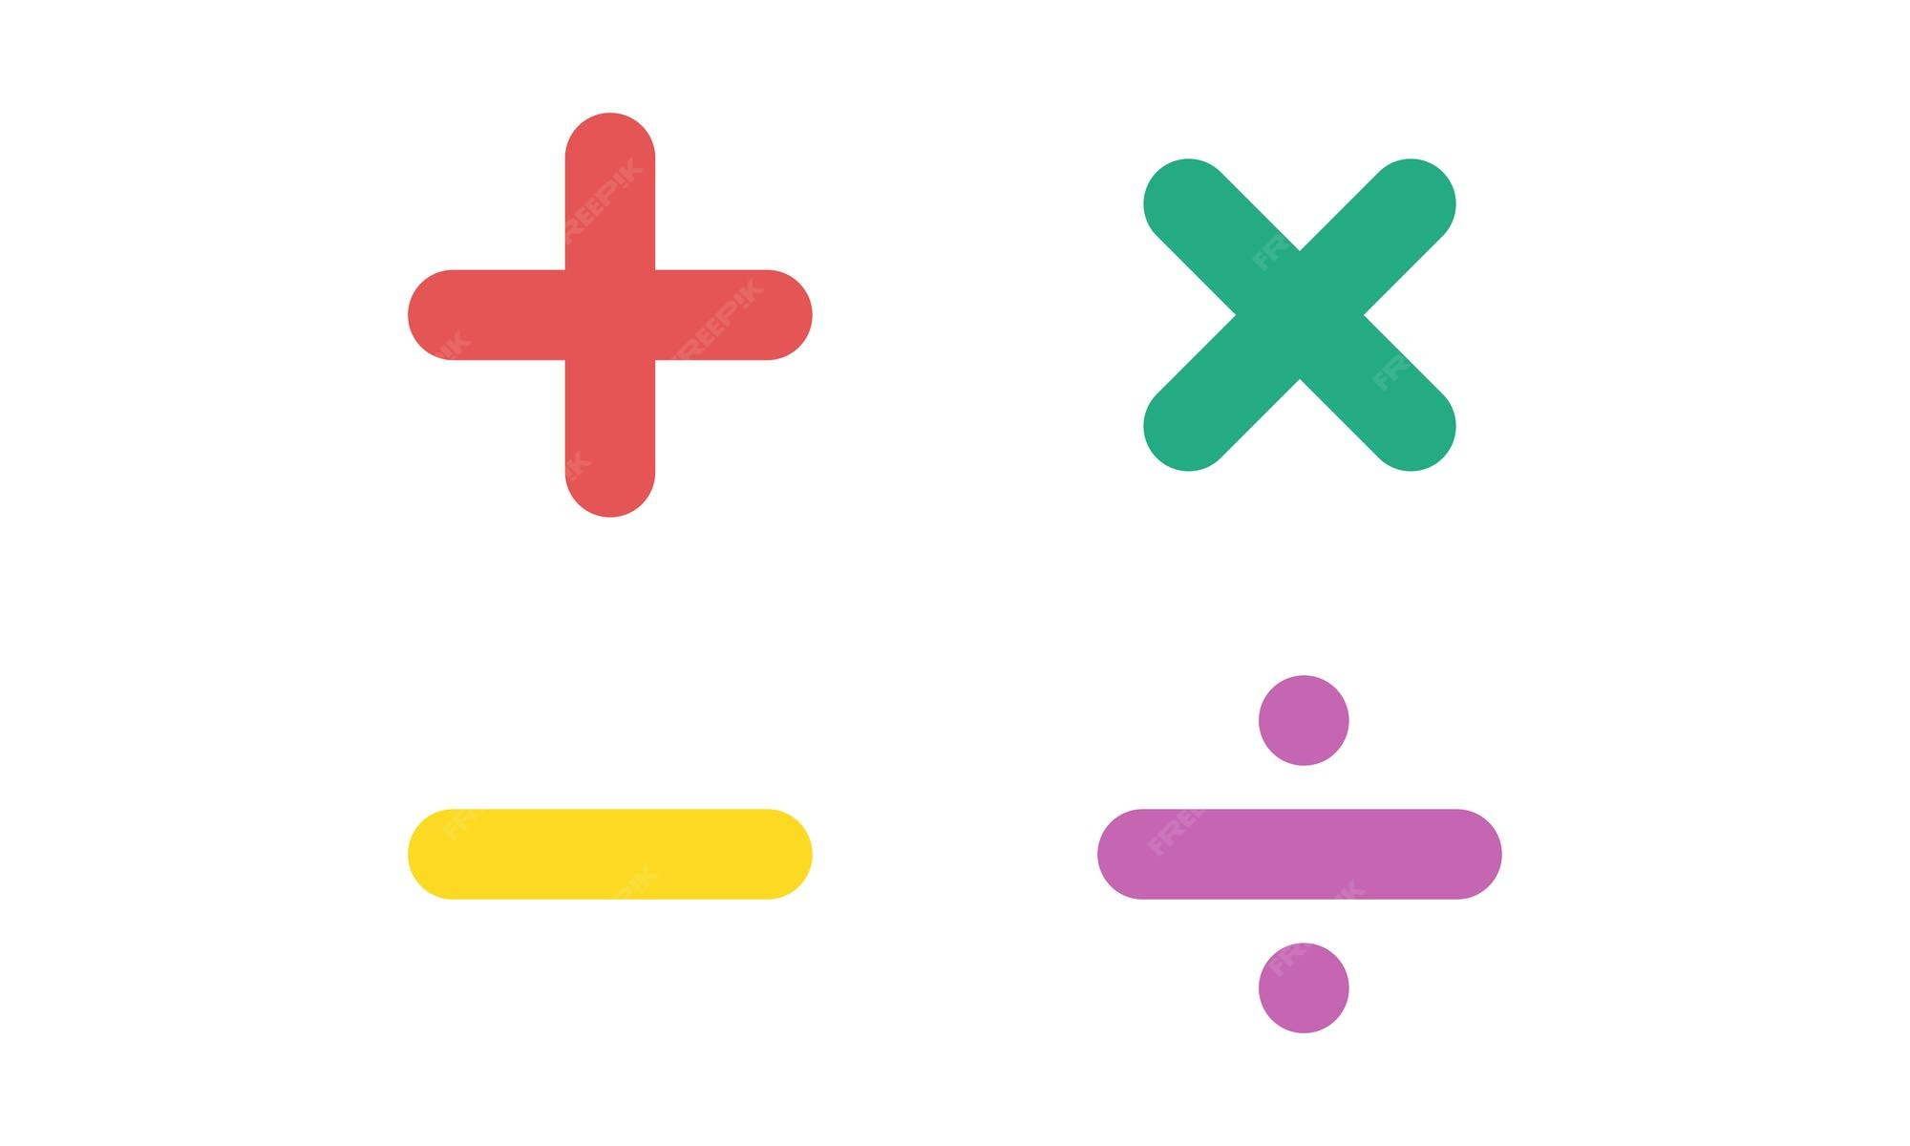

PE
Mondays – Fencing with Key PE
Wednesdays – Gymnastic skills
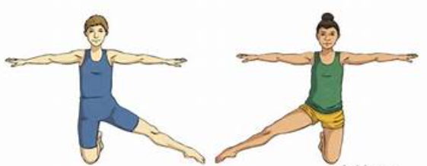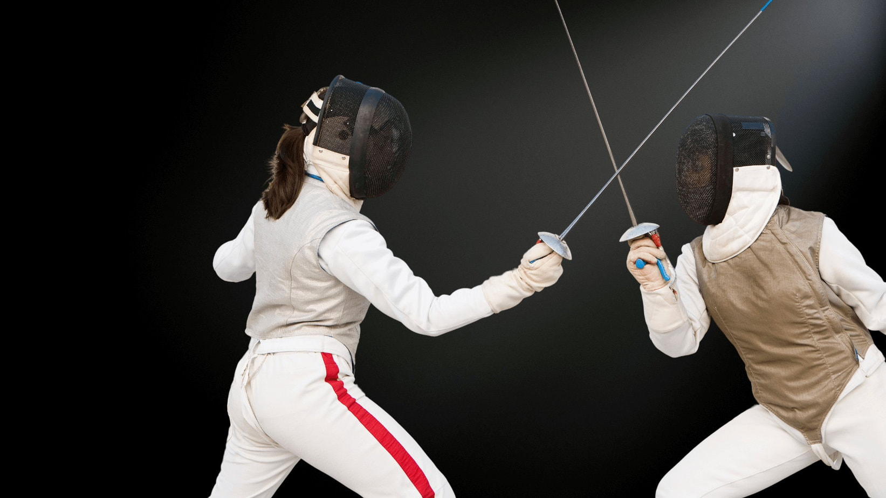

Computing – Networks
We will be learning about the concept of networks, how devices communicate. We will explore examples of real-life networks.
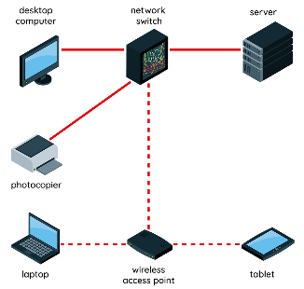

PSHE – Health & Wellbeing
We will learn how to plan for a healthy lifestyle with physical activity, a balanced diet and rest. We will explore our own identities through the groups we belong to. We will explore our strengths and break down a problem into smaller steps to overcome it.
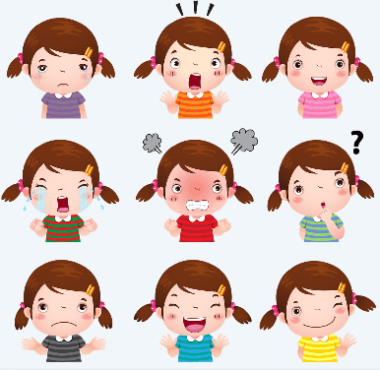

Science – Forces and Magnets

We will be exploring contact and non-contact forces, including friction and magnetism and their effects.
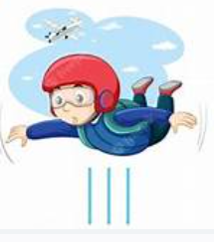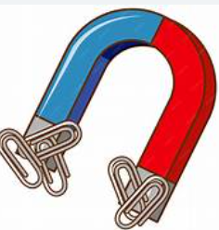

Art – Painting & Mixed media – Prehistoric painting

We will be exploring prehistoric art, recreating the style of cave artists using charcoal and natural pigments.
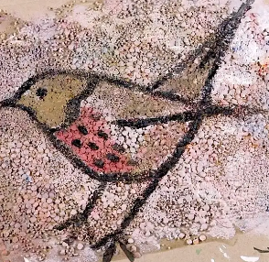
.

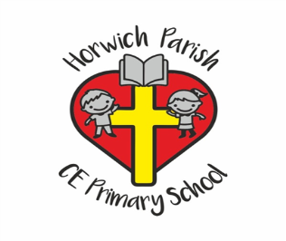
3B
Autumn 2
History – Would you prefer to have lived in the Stone Age, Bronze Age or Iron Age?
We will learn about the earliest settlements in Britain and how settlements changed over time.
