Design and Technology Policy

Horwich Parish CE Primary School

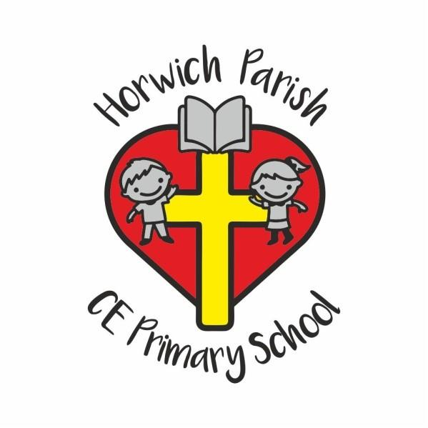

Approved by: School Improvement Committee |  | Date: Jun-24
Author: DM |  | Version: 1
Last reviewed on: | Jun-24
Next review due by: | Jun-26

Contents
Section |  | Page
1 | Purpose of the Policy | 3
2 | Subject Vision | 3
3 | Aims and Outcomes | 3
4 | Teaching and Learning | 4
5 | Curriculum Overview | 4
6 | Cross-Curricular Links | 8
7 | Assessment and Recording | 8
8 | Resources | 9
9 | Roles and Responsibilities | 9
10 | Inclusion | 10
11 | Links to Other Policies | 11
12 | Monitoring and Review | 11

1. Purpose of the Policy
This policy reflects the aims and values of Horwich Parish CE Primary School. It ensures all stakeholders, including staff, governors, parents and pupils, are working towards the same goals.
The purpose of this policy is to:
- Set out a framework for all teaching and non-teaching staff, giving guidance on planning, teaching and assessment.
- Demonstrate adherence to the National Curriculum objectives and guidelines.
- Provide clear information to parents and carers about what their children will be taught.
- Allow the governing board to monitor the curriculum.
- Provide OFSTED inspectors with evidence of curriculum planning and implementation.
This policy will be available on our school website.

2. Subject Vision
At Horwich Parish CE School we follow Kapow and we believe that Design and Technology prepares children to take part in the development of tomorrow’s rapidly changing world. Creative thinking encourages children to make positive changes to their quality of life. The subject encourages children to become autonomous and creative problem-solvers, both as individuals and as part of a team. It enables them to identify needs and opportunities and to respond by developing ideas and eventually making products and systems.

3. Aims and Outcomes
By the time pupils leave the school, they should be able:
- To develop imaginative thinking in children and to enable them to talk about what they like and dislike when designing and making.
- To enable children to talk about how things work, and to draw and model their ideas.
- To encourage children to select appropriate tools and techniques for making a product, whilst following safe procedures.
- To explore attitudes towards the made world and how we live and work within it.
- To develop an understanding of technological processes, products, and their manufacture, and their contribution to our society.
- To foster enjoyment, satisfaction and purpose in designing and making.

4. Teaching and Learning
DT is taught in single and mixed age classes, dependent on the classes, by class teachers. Lesson plans are based around the subject’s long-term plan (see Kapow’s scheme of work) and resources available, with objectives adapted to suit the stage of development for the pupils in each class. The teaching of DT will involve:
- Whole-class teaching.
- Small group discussions.
- Role play

5. Curriculum Overview
Here at Horwich Parish CE Primary School the pupils will follow the Kapow Scheme of Work.
Kapow provides the following documents to show the gradual development of learning, the outcome being the acquisition of knowledge and skills that enable each pupil to enquire, research and analyse.
  - DT Progression of Knowledge and Skills
At Horwich Parish CE School all children are encouraged to:
- Generate ideas through discussion and experimentation.
- Extend knowledge and understanding of a wide range of materials, including construction kits, textiles, food, wood, plastic, metals and reclaimed/junk materials.
- Work within groups and as individuals.
- Make use of drawings and models to communicate their ideas.
- Evaluate their work and identify strengths and weaknesses in a positive way.
- Experiment with simple components, mechanisms and structures.
- Learn about health and safety aspects when working with a variety of materials and tools.
- Consider risk to themselves and to others and build up a knowledge and understanding of the dangers inherent in certain products and tools.
- Experience Design and Technology through off-site visits, where practical, in order to see technology used in a real environment.
At Horwich Parish CE School children learn how to draw on a developing repertoire of skills and knowledge, which will include:
- Learning how to work independently and collaboratively.
- Developing, planning and communicating ideas.
- Working with tools, equipment, materials and components to make quality products.
- Evaluating processes and products.
- Developing knowledge and understanding of materials and components.
- Learning the importance of health and safety.

  - Long Term DT Planning
At Horwich Parish CE School planning is the responsibility of the class teacher. The scheme of work contains suggested activities and skills to ensure progression and continuity throughout the school. In planning, the delivery of the curriculum will be differentiated to allow for children of all abilities. The scheme of work is set out in three main sections:
- Investigate, disassemble and evaluate activities.
- Focused practical tasks.
- Design and make projects.

Foundation Stage and Key Stage 1
At Horwich Parish CE School during Key Stage 1 the children learn how to think imaginatively and talk about what they like and dislike when designing and making. They build on their early childhood experiences of investigating objects around them. They explore how familiar things work and talk about, draw and model their ideas. They learn how to design and make safely and could start to use ICT as part of their designing and making.

Key Stage 2
At Horwich Parish CE School during Key Stage 2 children work on their own and as part of a team on a range of designing and making activities. They think about what products are used for and the needs of the people who use them. They plan what has to be done and identify what works well and what could be improved in their own and other people’s designs. They draw on knowledge and understanding from other areas of the curriculum and use computers in a range of ways.

In Foundation, Key Stage 1 and Key Stage 2 children will:
- Develop knowledge, skills and understanding.
- Use developing, planning and communicating ideas.
- Gain a knowledge and understanding of materials and components.
- Carry out focused practical tasks that develop a range of techniques, skills, processes and knowledge.
- Design and make assignments using a range of materials, including electrical and mechanical components, food, mouldable materials, stiff and flexible sheet materials, and textiles.
- Investigate and evaluate a range of familiar products, thinking about how they work, how they are used and the views of the people who use them.
- Allow constructive conversation and language interaction between.

Intent, Implementation and Impact Plan
At Horwich Parish CE School through the study of Design and Technology children combine practical skills with an understanding of aesthetic, social and environmental issues. This allows them to reflect on and evaluate present and past design and technology, its uses and its impacts.
Design and Technology helps all children to become discriminating and informed consumers and potential innovators.
At Horwich Parish CE School children learn to produce practical solutions to real problems. Children develop technical understanding and making skills, learn about design methods and investigate their environment and the materials around them.
At Horwich Parish CE School we use a variety of teaching and learning styles in Design and Technology lessons. The principal aim is to develop children’s knowledge, skills and understanding in Design and Technology, and teachers encourage children to use their knowledge and understanding when developing ideas, planning and making products and evaluating them.
At Horwich Parish CE School we use a balance of whole-class teaching and individual/group activities, giving children the opportunity to both work on their own and to collaborate with others.
At Horwich Parish CE School children are encouraged to listen to the ideas of others, and treat them with respect, to critically evaluate existing products, both their own work and those of others. They have the opportunity to use a wide range of materials and resources, including ICT.

National Curriculum coverage and National Curriculum mixed-age coverage
These documents show all the National Curriculum targets and which units work towards them.

Programmes of Study at Horwich Parish CE Primary School
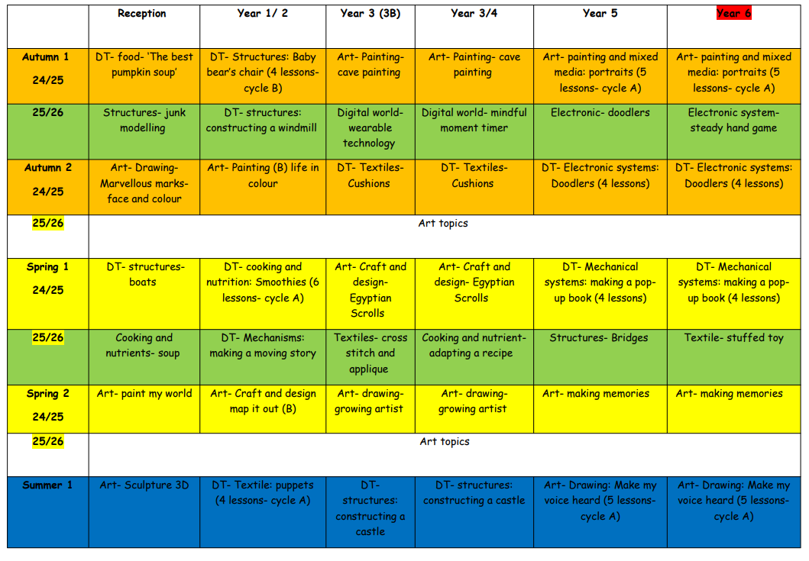
6.Cross-Curricular Links
This curriculum allows for cross curricular links including SMSC which encourages empathy towards other cultures and religions, and reflection on moral issues. (see separate statement documents for SMSC and Bucket Lists).

7. Assessment and Recording
7.1 Assessment
Horwich Parish CE Primary School uses assessment to enable staff to understand what pupils have learnt before, what they need to learn now and what they will learn next.
Formative Assessment
There is a Kapow retrieval activity at the start of every lesson with at least one of these activities or a separate written metacognition exercise completed per unit and found in every child’s foundation book. Assessment is used to inform planning and to facilitate differentiation. The assessment of children’s work is on-going to ensure that understanding is being achieved and ensure progress is being made. Feedback is given to the children as soon as possible and marking work will be guided by the school’s marking policy

Summative Assessment
The Kapow assessment materials (multiple choice) are used at the start and end of each unit. The is a mark scheme to follow on Kapow. The class teacher makes a summary judgement of the work for children and considers whether the child is working towards, age related or greater depth plus SEN and pupil premium children are also identified. The mark is recorded on SIMS. Comparing the pre and post unit assessments allows teachers and the subject leader to gauge the progress of individuals and groups of pupils.
7.2. Marking
Children receive regular feedback and marking follows the school’s marking policy.
7.3 Recording
In Key Stage 1 and Key Stage 2 the children each have their own foundation book to record their work.
In EYFS the children’s work is mainly practical.
Recording may take the form of photographs, pictures, notes or written work, and may be worksheet-based or fully independent. In EYFS, assessment of geographical knowledge and skills are considered as part of the judgement for the ‘Knowledge and Understanding of The World’ aspect of learning.

8. Resources
8.1 Textbooks and other equipment
Besides using the Kapow scheme as a resource), the children will use a variety of different resources which can be found in the resource list.
8.2 External speakers, local museums, trips
Refer to the school’s Bucket List document.

9. Roles and Responsibilities
9.1 Headteacher
The Headteacher and curriculum leader at our school will:
- Support the subject leader but also hold them to account for the effectiveness of the subject.
- Support staff through the provision of training and resources.
- Monitor the planning and delivery of the subject.
- Ensure the requirements of the National Curriculum are met.
- Ensure this policy is reviewed according to the timescales set out.
9.2 Subject Leader
The subject leaders at our school will:
- Monitor Design and Technology within the school e.g., through curriculum walks.
- Keep up to date with new developments and inform staff.
- Encourage other members of staff in their Design and Technology teaching and give support where appropriate.
- Ensure that Design and Technology resources are available and appropriate to the needs of the staff.
- Ensure that Design and Technology keeps an appropriate profile within the school, through displays etc. (e.g., by carrying out a curriculum walk every term and reporting findings to teachers and by updating the school Design and Technology display every term, reflecting progression throughout the school).
- Keep a portfolio for Design and Technology that will include photographs of children at work, curriculum walk reports, examples of planning and examples of children’s work.
- Audit resources regularly and take overall responsibility for equipment and resources.
  - Classroom Teacher
Classroom teachers at our school will:
- Teach and assess the subject according to the principles laid out in this policy.
- Support subject leader during monitoring activities.
- Maintain subject knowledge and appropriate CPD.

10. Inclusion
Teachers set high expectations for all pupils in DT. The school uses the KAPOW assessments prior to starting the unit in order to assess the needs for all pupils including:
- More able pupils.
- Pupils with low prior attainment.
- Pupils from disadvantaged backgrounds.
- Pupils with special educational needs (SEN).
- Pupils with English as an additional language (EAL).
Teachers will adapt KAPOW’s activities/resources/outcomes so pupils with SEN, EAL and/or disabilities can access the DT curriculum; more able children will have opportunities to demonstrate their skills, knowledge and understanding.
Further information can be found in our statement of equality information and objectives, and in our SEN policy and information report.

11. Links to Other Policies
This subject policy links to the following policies and procedures:
- Curriculum policy
- Assessment policy
- Marking policy
- SEN policy

12. Monitoring and Review
This policy will be reviewed by staff and governors every 2 years.

