RE
Why do Christians believe that Jesus was the messiah?
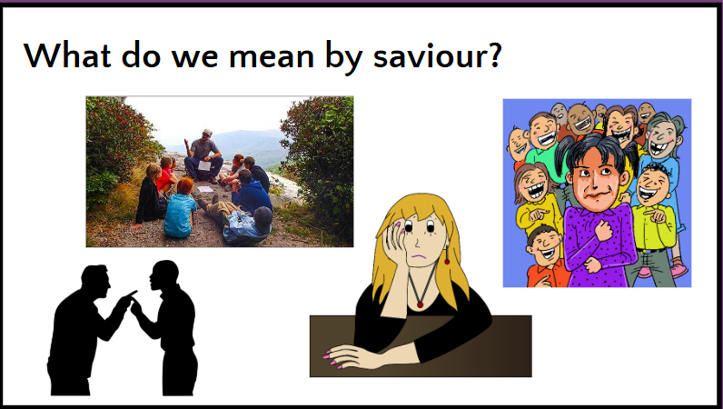

Music
Film Music
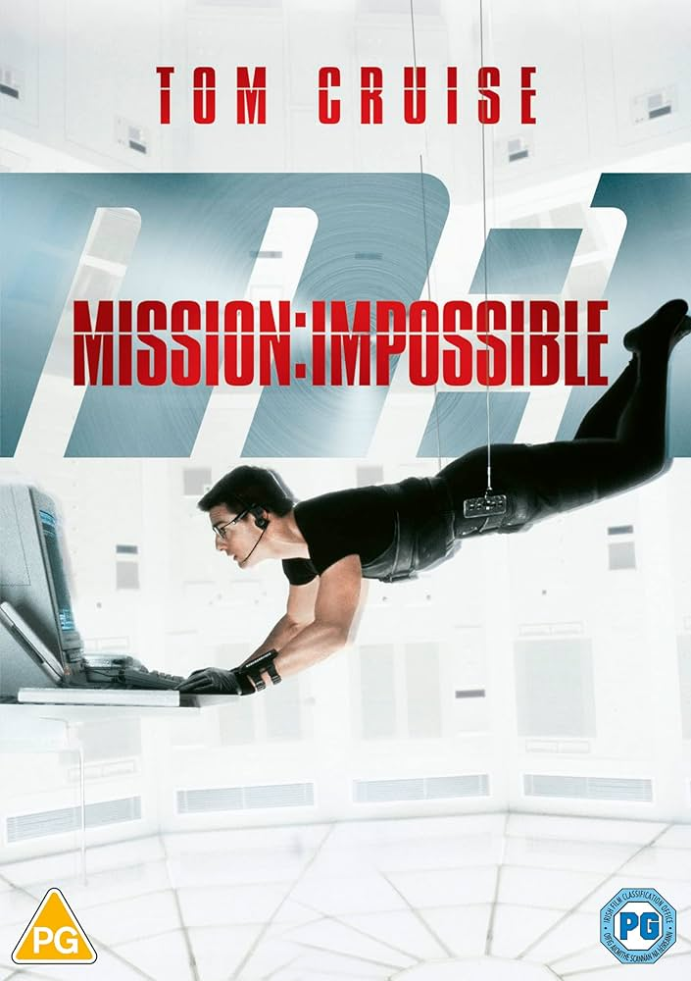

Maths
Fractions
Geometry, Position and Direction
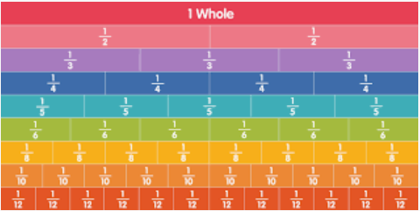
English
An information leaflet on the Windrush generation.


Year 6
Autumn 2 2025
PSHE
Health and Wellbeing

Art
Craft and Design: Architecture

Science
Materials: properties and change
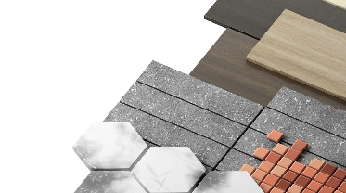
Computing
Computer systems and networks: Exploring AI

History
Were the Vikings raiders, traders or something else?
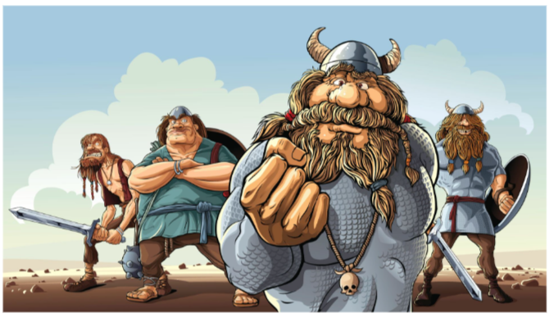

PE
Gymnastics

