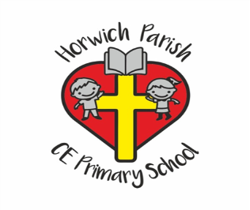
Year 5
Autumn 2
English 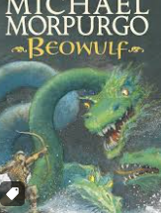
In writing skills we will be using Beowulf by Michael Morpurgo to write a story.
In reading skills, we will be reading ‘Viking Boy’.
Science
We will be studying Materials and studying how to classify different types of materials and changes to materials.
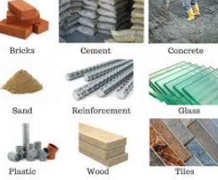
PE 
Swimming
Gymnastics
RE
We will be studying why Christians believe Jesus was the messiah.
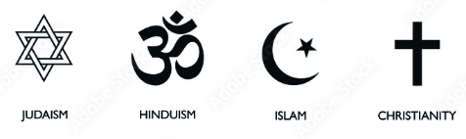
PSHE
We will be learning about health and wellbeing.

Music
We will be studying blues music.
Art and Design
This half term we will be studying craft and design - architecture.
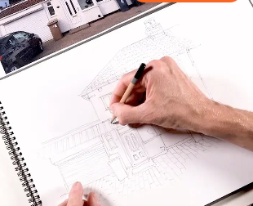
History
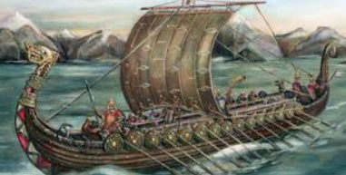
In history, we will be studying the Viking era with a focus on where they went and what life was like during that time period.
Maths 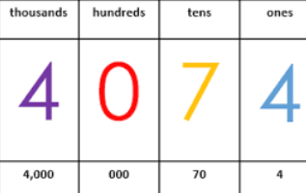
Number and Place Value
Addition and Subtraction
Multiplication and Division
Computing
Throughout this half term, we will be studying programming.

