Maths
We will continue to focus on addition and subtraction. We will explore all of the calculations included in a ‘fact family’.
Science
In the topic ‘Everyday Materials’ we will focus on learning the difference between waterproof and absorbent and test different materials to see how sturdy they are.


RE
We will be exploring the key question ‘Why is Christmas important to Christians?’
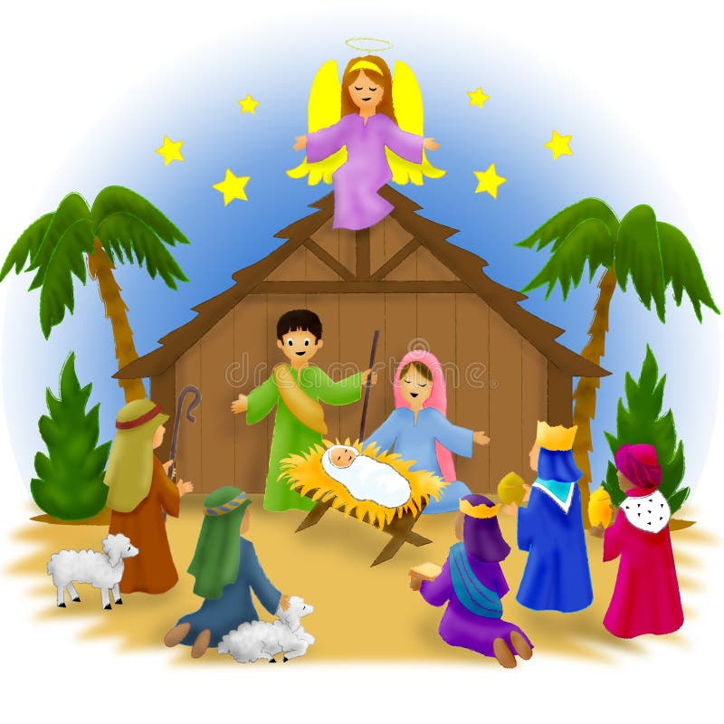

Music
Tempo
The story of snail and mouse
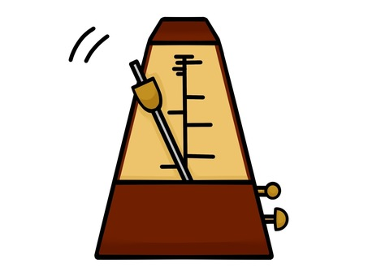

Computing
Computing systems and networks: mouse skills.


English
We will continue to follow the structure of ‘Drawing Club’ to support children’s independent writing.
We will focus on the Year 1 skill of capital letters and full stops, adjectives and punctuation (? !).


History
How am I making history?
In this topic, children will explore special events in their lives that are part of their history.
We will also be comparing our lives to the past; exploring things that have changed and things that have stayed the same.

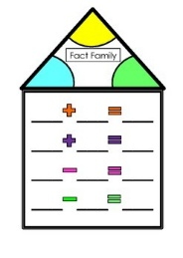



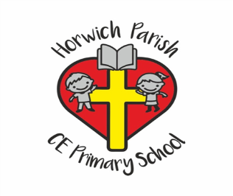
Year 1
Autumn 2 2025

PE
Gymnastics

PSHE
Health and well-being

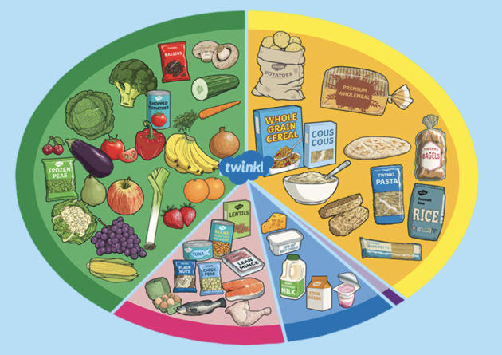
Art
Sculptures – paper play
We will be exploring 3D drawings, tube towers and paper spiders.
