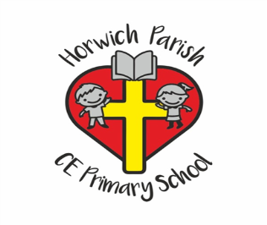
Year 5
Autumn 1
English 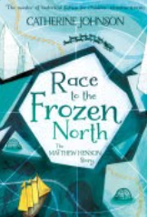
In writing skills we will be using ‘Young, Gifted and Black’ as well as ‘Race to the Frozen North’ to create a diary entry.
In reading skills, we will be reading ‘Viking Boy’
Science
We will be studying mixtures and separation with a focus on methods of separating.
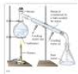
PE 
Swimming
Fundamental Movement
RE
We will be studying what it means to be a Muslim in Britain today.

PSHE
We will be learning about families and relationships.

Music
We will be studying composition notation.
DT
This half term we will be studying electrical systems and creating electrical doodlers.
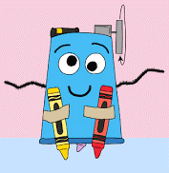
Geography
In geography we will be carrying out a geographical study of The Alps.
Maths 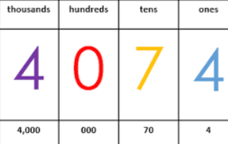
Number and Place Value
Addition and Subtraction
Multiplication and Division
Computing
Throughout this half term, we will be studying internet safety.

