PE
Mondays – Boxing with Key PE
Wednesdays – Fundamental movement skills

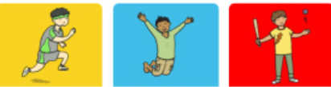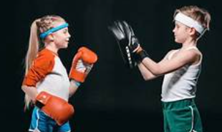

Computing – Online safety
We will be learning about:
- Beliefs, opinions and facts on the internet
- Sharing of information
- Rules of social media platforms
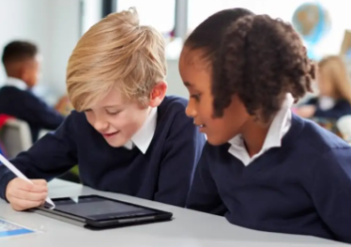

PSHE – Families and relationships
We will learn about:
- Healthy families
- Friendship and conflict
- Respecting differences
- Stereotyping
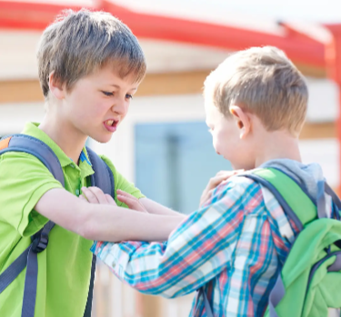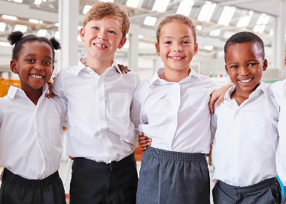

Science – Movement and Nutrition

We will learn about:
- The skeleton and bones on our body
- Muscles and movement
- Nutrient groups and a balanced diet
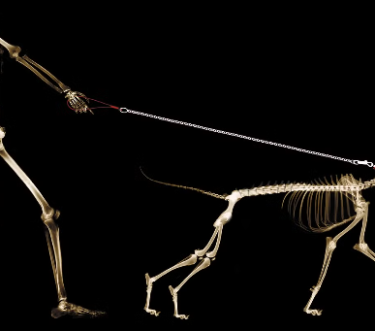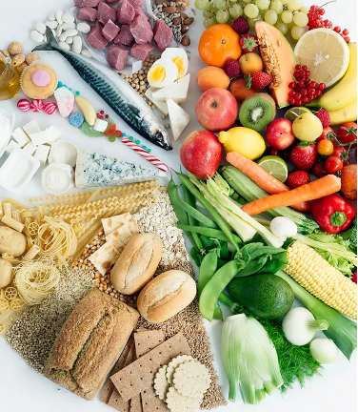

English – Seal Surfer by Michael Foreman
We will be building our writing skills to write a letter from the boy to his grandfather.

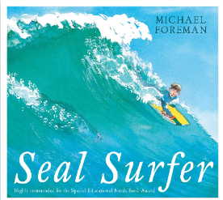
Maths – Place value, Addition and subtraction

We will learn to:
- Represent, partition, compare and order numbers up to 1000.
- Add and subtract up to 3 digit numbers.
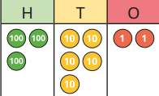

DT – digital world wearable technology
We will be learning:
- To evaluate electronic wearables.
- To design a light-up wearable.
- To program
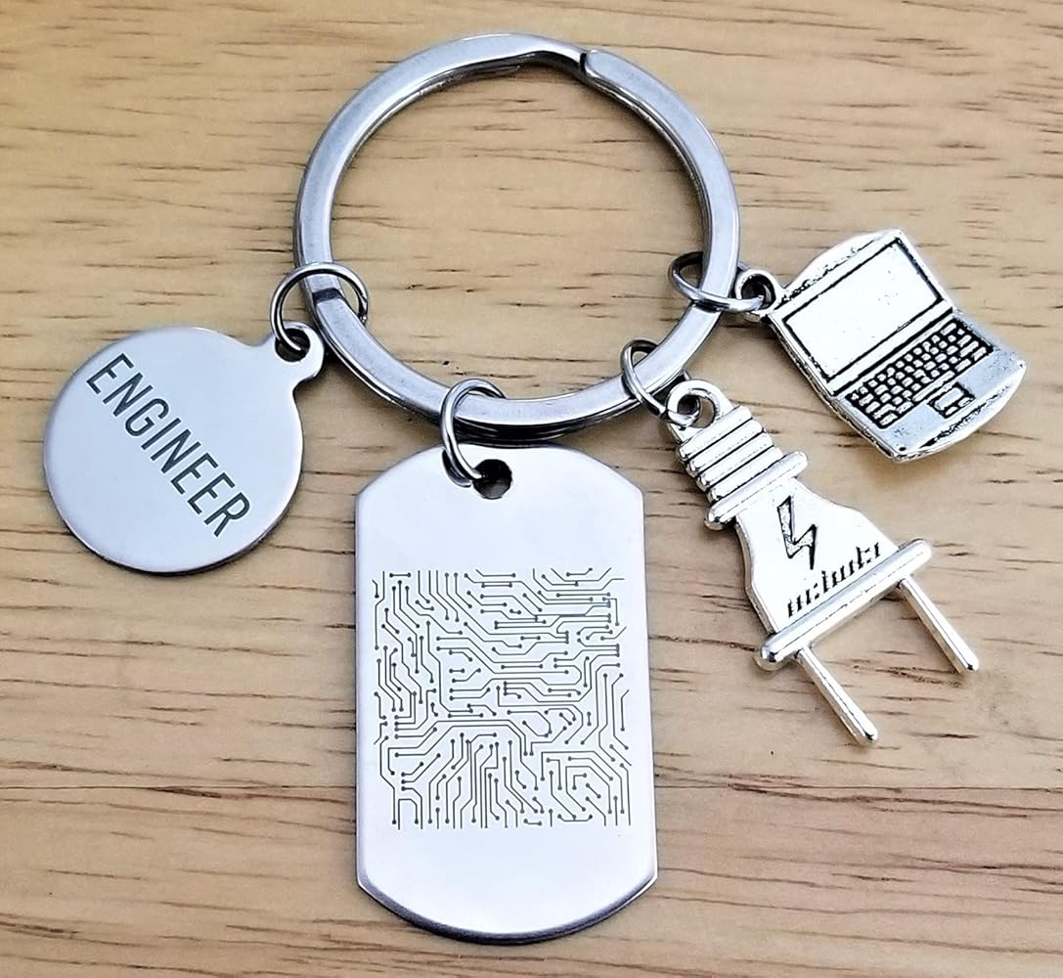.

Music – Ballads
We will be learning about:
- Ballad structure and the story behind the song
- Composing and performing a ballad
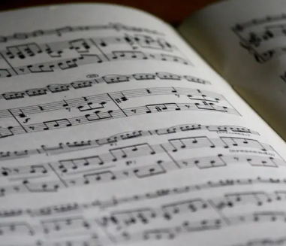

RE – What is it like for someone to follow God?
We will be learning about the Old Testament people of God and how they lived their lives. 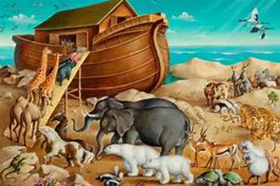

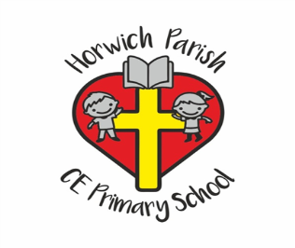
3B
Autumn 1
Geography – Volcanoes
We will learn about:
- The layers of the Earth
- Mountains
- Volcanoes and eruptions
- Earthquakes
- Rocks around school


