Computing 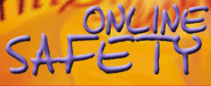
Online safety
We will be learning about:
- What happens when I search online?
- How do companies encourage us to buy online?
- What is a bot?

Art / DT 
We are doing DT this term and we will be doing digital world: mindful moment timer
We will be:
- Analysing timers
- Designing for the user
- Programming the timer

PSHE 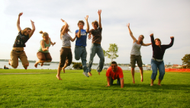
This term the children will be learning about Families and relationships
We will be learning about:
- Respect and manners
- Healthy relationships
- How my behaviour affects others?

PE 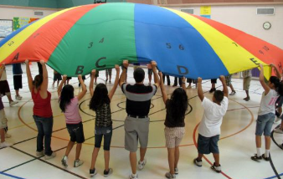
This term we will be focusing on fundamental movements.

Science 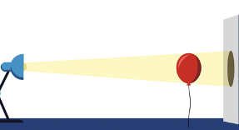
We are going to be learning about Light and Shadows
The children will learn about:
- The source of light
- What is reflection?
- Where do shadows come from?

History / Geography 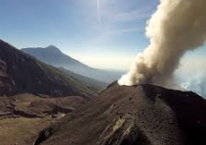
This term we will be focusing on Geography - Why do people live near volcanoes?
We will be learning:
- How is the Earth constructed?
- Where are mountains found?
- Why and where do we get volcanoes?

Music 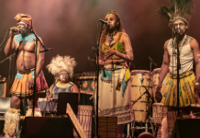
South Africa (instrumental lessons)
We will be learning
- Minims
- Semibreves
- Crotchets and rests
RE 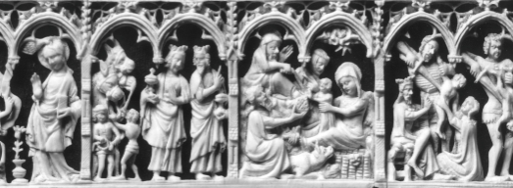
We will be learning about: What did Christians learn from the creation story?
We will be learning about:
- The creation story
- Our opinions
- Opinions of Christians

English
The children will learn how to write a narrative based on the story of ‘Gorilla’.
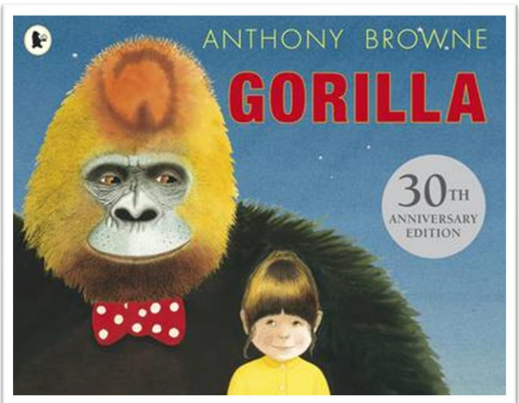
Maths 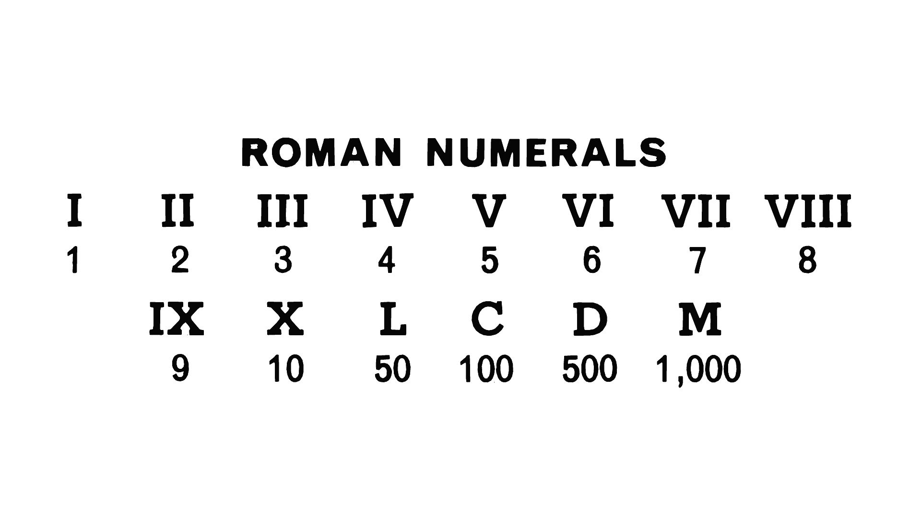
Place Value
Children will learn:
- Partitioning
- Number line to 1,000
- Numbers to 10,000
- Roman numerals

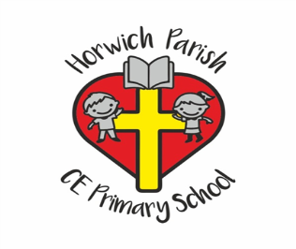
3/4L
Autumn one

