
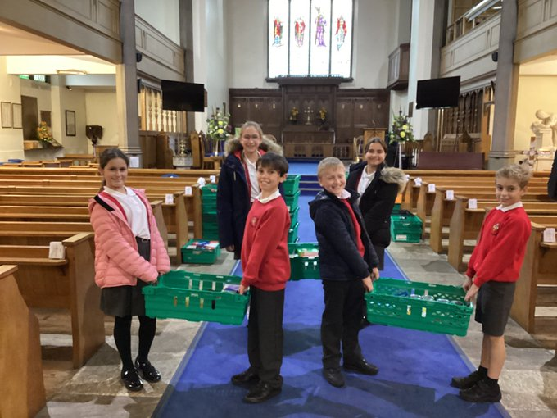
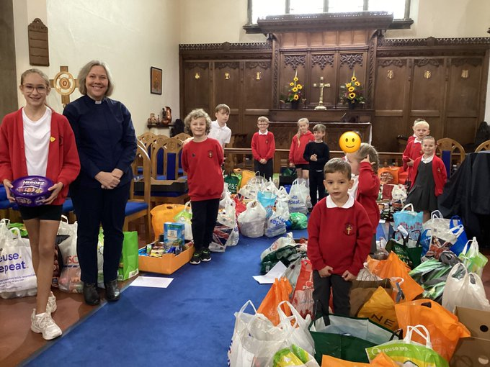
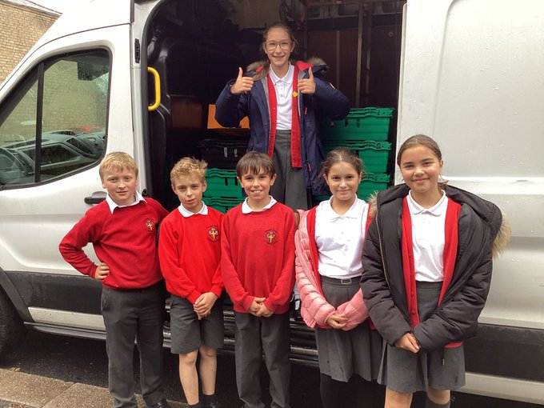

As a school we collected over a 1000 items for Urban Outreach. Reverend Nicola Gillard came to Holy Trinity as a representative of Urban Outreach to share our Harvest service with us. A number of pupils were lucky enough to visit the warehouse and deliver out contribution.
Harvest 2022

