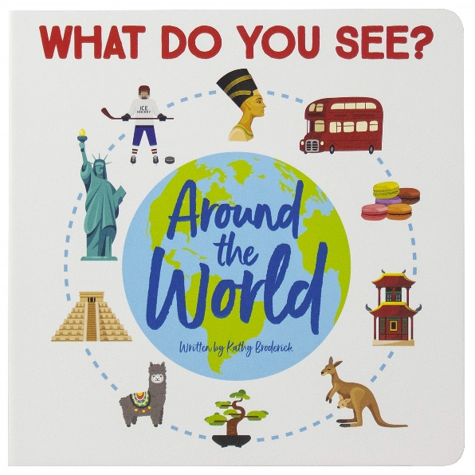
Geography
Around the world
To locate different countries and describe the characteristics and features of each place.

PSHCE
Relationships
be able to name a range of feelings
understand why we should care about other people’s feelings
be able to see and understand bullying behaviours
know how to cope with these bullying behaviours

RE
Jesus – friend to everyone
enjoy these stories of Jesus’ Miracles and to increase the children’s awareness that Jesus was an extraordinary person who welcomed everyone as a friend
Around the world
Spring 1
Curriculum Newsletter
DT
Fruit and vegetables
Describe fruits and vegetables and explain why they are a fruit or a vegetable.
- Name a range of places that fruits and vegetables grow.
- Describe basic characteristics of fruit and vegetables.
- Prepare fruits and vegetables to make a smoothie

Maths
Money
Multiplication and division
Length and height
Mass, capacity and temperature
English
Writing a letter to the Earth.
Writing a non chronological report
Commas in a list
Conjunctions
Similes
Verbs and adverbs
Collective nouns

Science
Animals including humans
How do animals and humans change as they grow
Dow e all grow the same
What do humans need to grow
What is a healthy diet?
Why do we need to have good hygiene

