Year 2 Year Ahead Summary
Summary of key information, curriculum and expectations
This document brings together the key information from the Year Ahead presentation into one easy-to-reference guide. The original visual examples from the presentation are included where they are particularly useful.

1. General Information
- PE days (Autumn 1): 2B – Tuesday and Wednesday; 2C – Tuesday and Thursday. Please be aware that PE days may change every half term.
- Homework, reading books and spellings are sent home on Monday.
- Reading: read daily at home, with the planner signed 3 times each week.
- Spellings: spelling practice 3 times each week.
- Numbots/ TTRockstars: use regularly to support number fluency and number-bond recall. Log in details can be found in your child’s planner.
- Comprehension: complete the weekly comprehension activity.
- Reading books should be brought into school every day.
- For non-urgent communication, contact the teacher via the Year 2 email: year2@horwichparish.net
- For immediate messages, please contact the school office.

2. Planners, Reading and Homework
Planners are used to record home reading and spelling practice. Reading should be completed at home and planners signed 3 times weekly. Children complete spelling practice in their planners; if spelling work is completed on separate paper, it will be stapled/stuck into the planner.
Home and school working together:
- Learn number bonds and begin times-table facts (2, 3, 5 & 10).
- Read 3 times a week with your child.
- Practise spellings 3 times a week.
- Develop handwriting and pencil-control skills.
- Keep talking to the class team.

3. Reading Expectations
Children will work on developing the following reading skills:
- Develop fluency.
- Read a range of different types of books.
- Take note of punctuation when reading aloud.
- Understand the meaning of new vocabulary in books.
- Retrieve information from texts to answer questions.
- Draw inferences from reading a text.
- Make predictions based on what has been read.

Reading VIPERS
Within our Reading Skills sessions, we follow the Reading VIPERS framework:
- V – Vocabulary: understanding words and their meanings
- I – Infer: using clues from the text to work things out
- P – Predict: making predictions based on what has been read
- E – Explain: explaining ideas and answers
- R – Retrieve: finding information directly from the text
- S – Sequence: putting events or information in the correct order
The presentation's example questions include multiple-choice retrieval questions, finding and copying a word from the text, explaining how the reader knows something, and sequencing events in the correct order.
Example reading questions
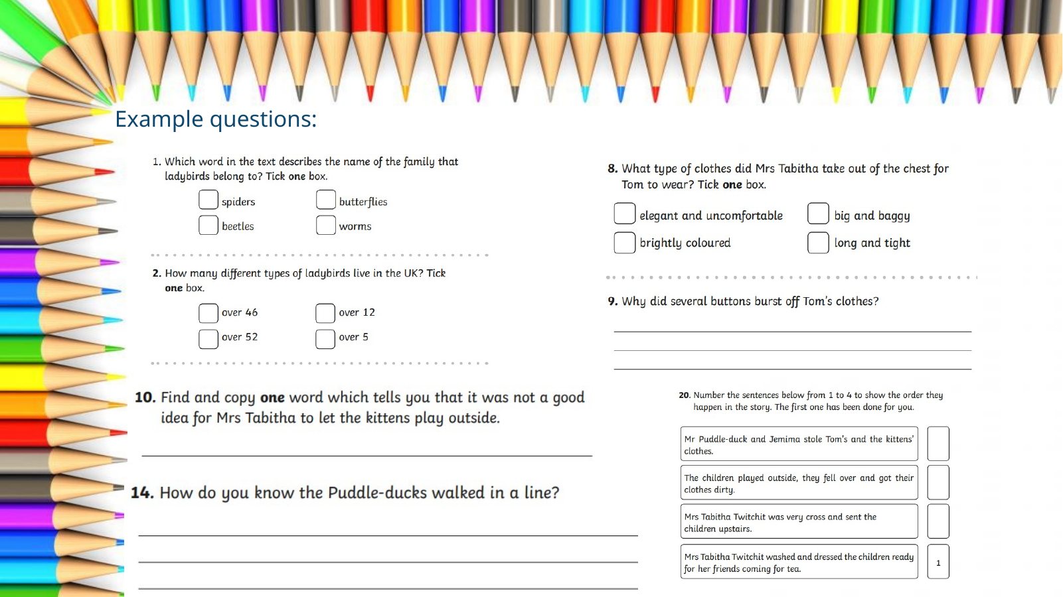

4. Writing Expectations
- Writing objectives are introduced and reinforced across different types of writing tasks and subjects.
- Grammar terms are constantly reinforced.
- Daily handwriting and retrieval are completed in books.
- Regular spelling activities take place throughout each week.
- Misconceptions are addressed at the start of each lesson.

Year 2 Writing Mat – key expectations
The presentation includes a Year 2 writing mat covering punctuation, spellings, suffixes, contractions, sentence types, tenses, joining words and descriptive noun phrases. The original visual is included below for reference.
Example of the end- of – year ‘expected standard’ writing mat
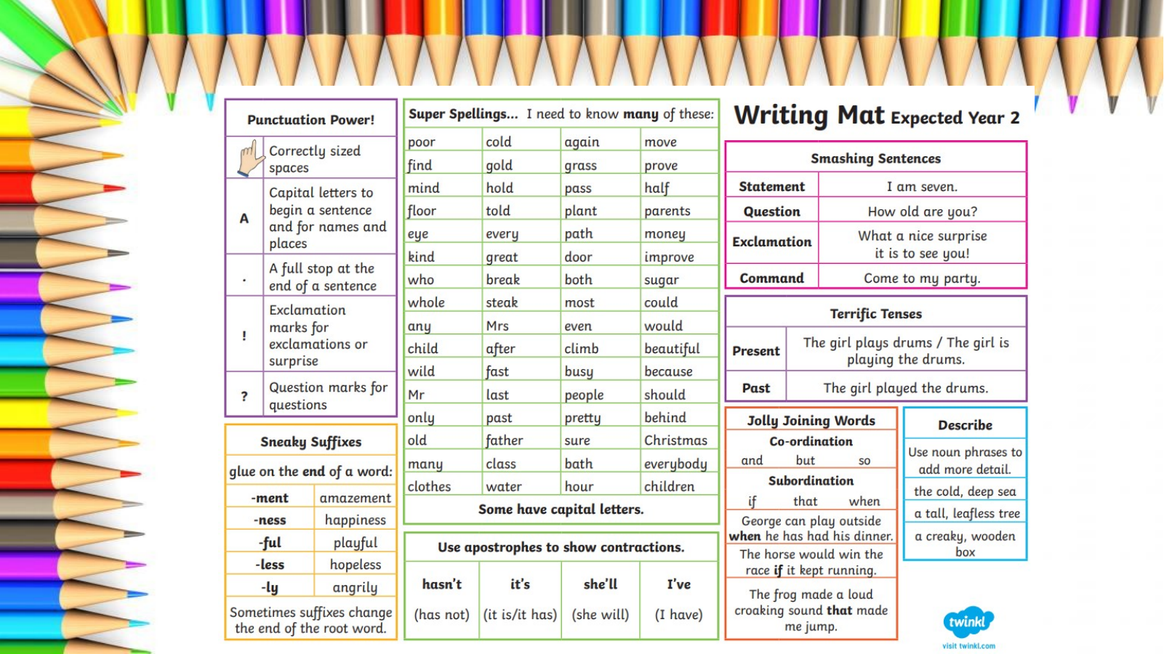

5. Maths
- Maths objectives are covered daily and applied across different subjects where relevant.
- A daily ‘Mastering Number’ session reinforces key skills and fast recall.
- Children work towards bronze, silver and gold awards in number bonds and times tables.
- Numbots and TTRockstars are recommended at home to support these skills.
- There is a strong focus on fluency in number.
- Times tables: 2, 3, 5 and 10 times tables.

Year 2 Maths curriculum overview
We follow White Rose Maths curriculum which also provides home learning videos if your child would like to practice at home. The curriculum overview is organised by term:
- Autumn term: Place value; Addition and subtraction; Shape.
- Spring term: Money; Multiplication and division; Length and height; Mass, capacity and temperature.
- Summer term: Fractions; Time; Statistics; Position and direction; followed by consolidation.

Year 2 Maths curriculum overview
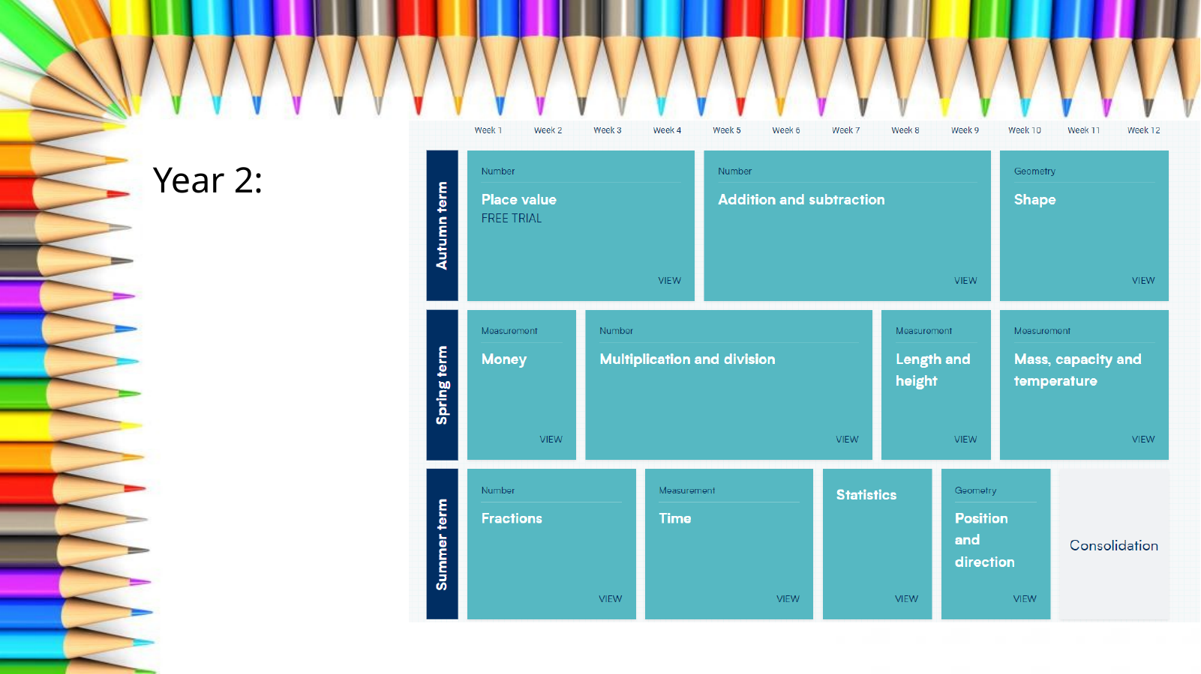

6. Quick Reference
Area
PE days for Autumn 1 | 2B: Tuesday and Wednesday  2C: Tuesday and Thursday
Homework/reading books/spellings | Sent home Monday
Reading | Daily; planner signed 3 times weekly
Spellings | 3 times weekly
Numbots/TTRockstars | Use to support number fluency, number bonds & times table facts.
Comprehension | Complete weekly comprehension
Reading book | Bring to school every day
Times tables | 2, 3, 5 and 10
Communication | year2@horwichparish.net; urgent messages via school office

