RE
We will be learning about: Unit 13 What is the good news Christians believe Jesus brings? (Gospel).
We will be learning to:
- Understand the Gospel and the good news Jesus brings.
- Explore forgiveness, peace and love through Jesus’ teachings.
- Learn how Christians follow Jesus’ example.
- Consider whether Jesus’ teachings have meaning for everyone.
English
The children will write a story based upon the book ‘Troll Swap’ by Leigh Hodgkinson.

Computing
This term the children will be learning about Online safety.
We will be learning to:
- Understand what online information is and what is safe to share.
- Create strong passwords and keep them secure.
- Ask for and give permission when sharing online.
- Know who to ask for help with online worries.
- Check whether online information is reliable.
Art / DT
The term we will be focusing on DT: Cooking and Nutrition: Balanced diet.
We will be learning to:
- Name the main food groups and identify foods that belong to each group.
- Describe the taste, feel and smell of a given food.
- Think of three different wrap ideas, considering flavour combinations.
- Construct a wrap that meets the design brief and their plan.

Music
This term the children will be learning about Call and response.
We will be learning to:
- Use dynamics and experiment with different sounds.
- Keep in time with a pulse and a group.
- Create and perform call- and- response patterns.
- Copy and play sound patters on instruments.
- Perform our own compositions.
PSHE
This term the children will be learning about: How can we look after our bodies?
We will be learning to:
- Make healthy movement and exercise choices.
- Understand the importance of sleep.
- Make healthy food and drink choices.
- Look after our teeth and develop healthy habits.
- Understand how healthy habits helps keep our body and mind healthy.
PE
This term the children will be focusing on ABC and Awareness.
We will be learning to:
- Develop agility, balance and coordination.
- Develop control and accuracy when moving.
- Develop team, communication and decision- making skills.
History / Geography
This term we will be focusing on Geography: ‘Hot or cold’.
We will be learning to:
- Locate the seven continents, the North and South Poles and the Equator on a world map.
- Recognise the features of hot and cold places.
- Locate countries with hot or cold climates on a world map.
Maths
This term the children will be learning Place Value & Addition and Subtraction.
We will be learning:
- Recognise, partition and write numbers to 100.
- Show 10s and 1s on the number line to 100.
- Estimate numbers on a number line.
- Bonds to 10 and 11.
- Add three 1 digit numbers.
- Add and subtract across a 10.

Science
We are going to be learning about Habitats!
We will be learning to:
- Recall the life processes of plants and animals.
- Identify plants and animals and their habitats.
- Understand how animals use habitats for food and shelter.
- Understand how plants make food and energy.
- Create and understand simple food chains.

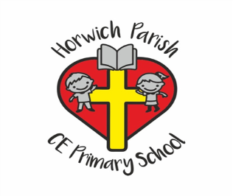
Year 2
Autumn 1

