RE 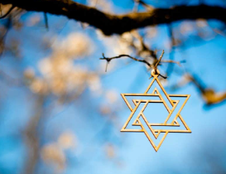
We will be learning about: How do festivals and family life show what matters to Jewish people?
We will be learning about:
- What people celebrate?
- How people celebrate?
Music 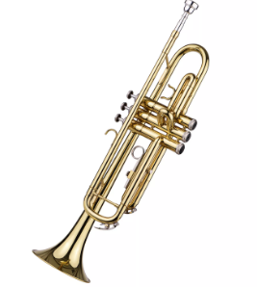
We will be continuing to take part in our Brass lessons.
PSHE 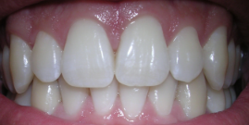
This term the children will be learning about Health and Well-being
We will be learning about:
- How to look after my teeth
- Relaxation
- My happiness
History / Geography 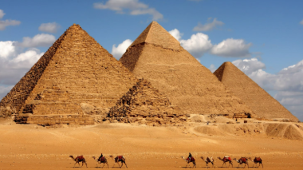
This term we will be focusing on History- What did the ancient Egyptians believe?
We will be learning:
- Links to the river Nile
- What we know about ancient Egyptian times.

English 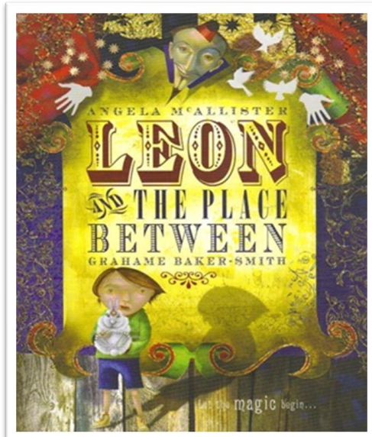
The children will learn how to write Leon’s secret diary about what really happened in ‘the place between’, including conversation between Leon and the boy.

Computing 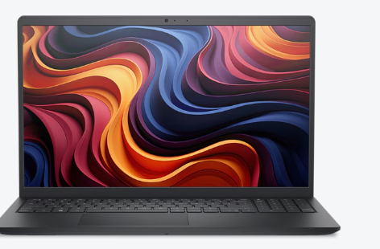
Computational thinking
We will be learning about:
- Decomposition and pattern recognition
- Abstraction
- Algorithm design
Art / DT 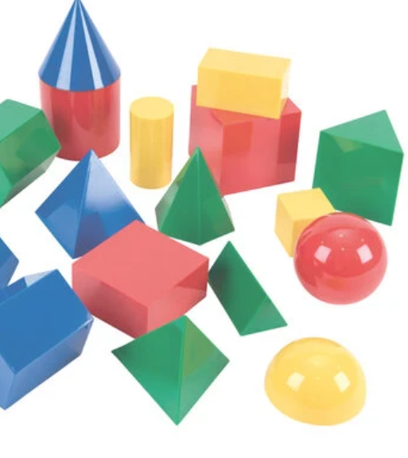
We are doing Art this term and we will be doing sculpture and 3D- abstract shape and space
We will be:
- Constructing 2D and 3D shapes.

PE 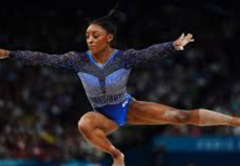
This term we will be focusing on gymnastics.

Science 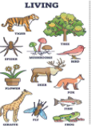
We are going to be learning about living things
The children will learn about:
- Living plants
- Habitats

Maths 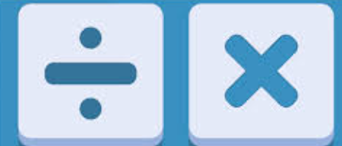
Multiplication
Children will learn how to:
- Their times tables.
- Multiples and divisions for 3, 6, 9, 7, 11 and 12.
- Common factors
- Prime numbers

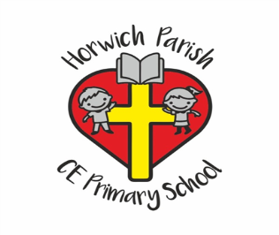
4/5H
Autumn two

