RE 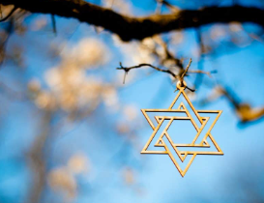

We will be learning about: How do festivals and family life show what matters to Jewish people?

We will be learning about:

* What people celebrate?
* How people celebrate?

Music 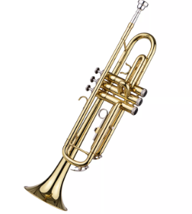

Developing singing techniques – The Vikings.

PSHE 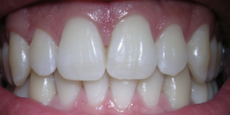

This term the children will be learning about Health and Well-being

We will be learning about:

* How to look after my teeth
* Relaxation
* My happiness

History / Geography 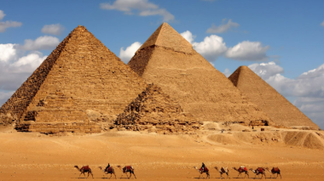

This term we will be focusing on History- What did the ancient Egyptians believe?

We will be learning:

* Links to the river Nile
* What we know about ancient Egyptian times.

English 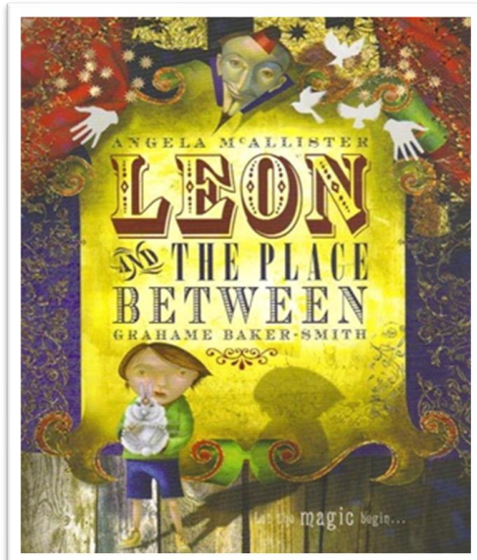

The children will learn how to write Leon’s secret diary about what really happened in ‘the place between’, including conversation between Leon and the boy.

Computing 

Computational thinking

We will be learning about:

* Decomposition and pattern recognition
* Abstraction
* Algorithm design

Art / DT 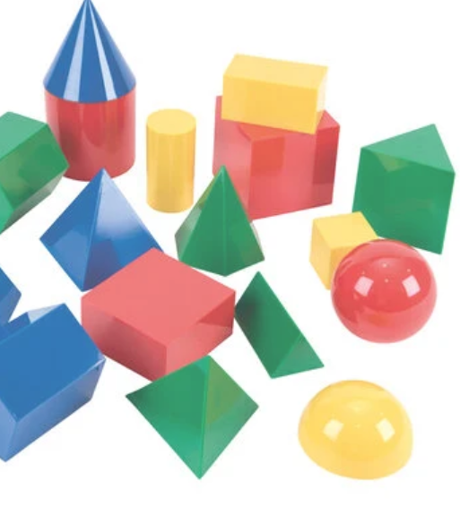

**We are doing Art this term and we will be doing sculpture and 3D- abstract shape and space**

We will be:

* Constructing 2D and 3D shapes.

PE 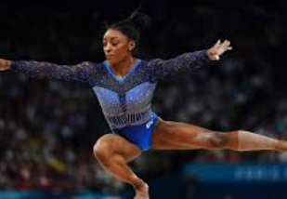

This term we will be focusing on gymnastics.

Science 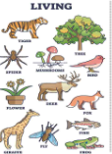

We are going to be learning about living things

The children will learn about:

* Living plants
* Habitats

Maths 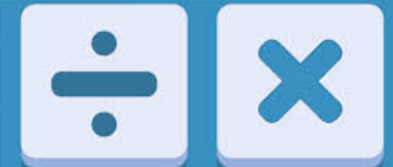

Multiplication

Children will learn:

* Their times tables.
* Multiples and divisions for 3, 6, 9, 7, 11 and 12.
* Common factors
* Prime numbers

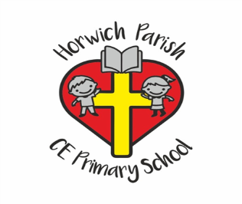

3/4L

Autumn two