PE

Mondays – Boxing with Key PE

Wednesdays – Fundamental movement skills

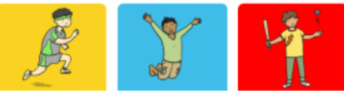 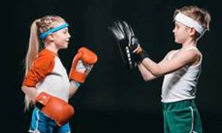

Computing – Online safety

We will be learning about:

* Beliefs, opinions and facts on the internet
* Sharing of information
* Rules of social media platforms

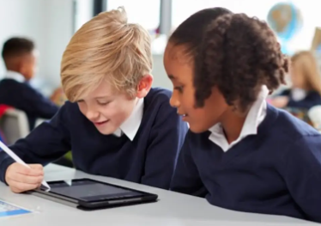

PSHE – Families and relationships

We will learn about:

* Healthy families
* Friendship and conflict
* Respecting differences
* Stereotyping

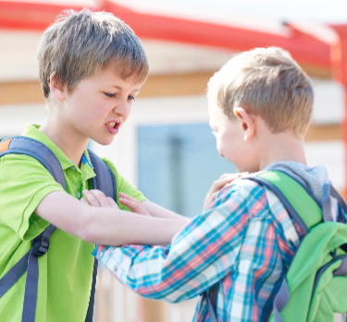 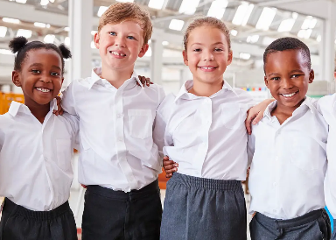

Science – Movement and Nutrition

We will learn about:

* The skeleton and bones on our body
* Muscles and movement
* Nutrient groups and a balanced diet

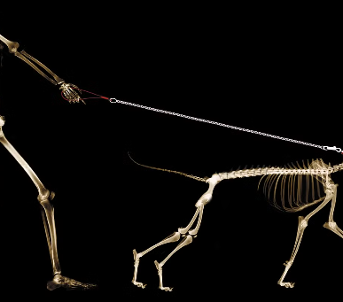 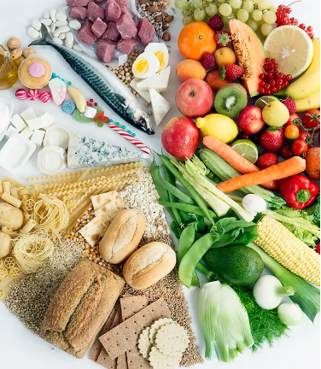

English – Seal Surfer by Michael Foreman

We will be building our writing skills to write a letter from the boy to his grandfather.

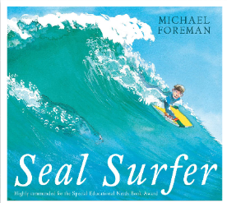

Maths – Place value, Addition and subtraction

We will learn to:

* Represent, partition, compare and order numbers up to 1000.
* Add and subtract up to 3 digit numbers.

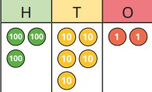

DT – digital world wearable technology

We will be learning:

* To evaluate electronic wearables.
* To design a light-up wearable.
* To program

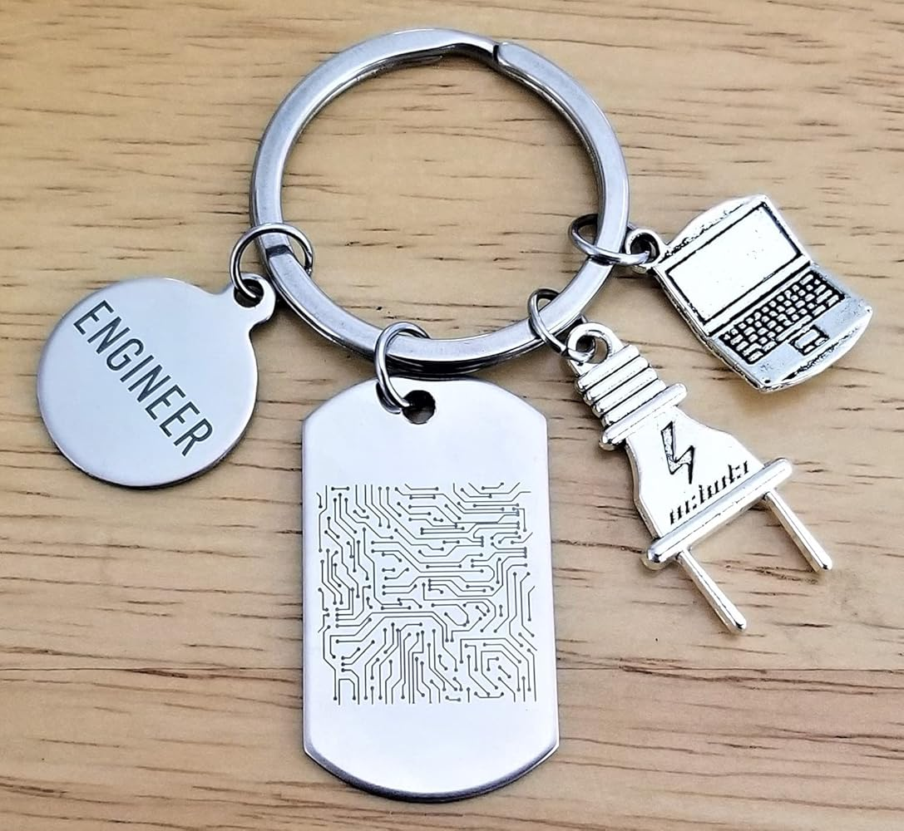.

Music – Ballads

We will be learning about:

* Ballad structure and the story behind the song
* Composing and performing a ballad

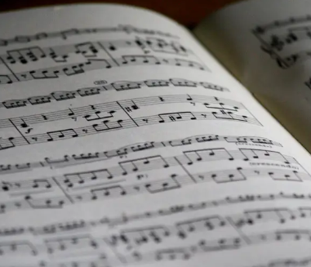

RE – What is it like for someone to follow God?

We will be learning about the Old Testament people of God and how they lived their lives. 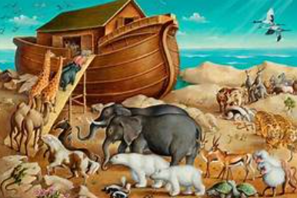

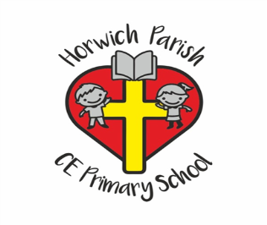

3B

Autumn 1

Geography – Volcanoes

We will learn about:

* The layers of the Earth
* Mountains
* Volcanoes and eruptions
* Earthquakes
* Rocks around school

