Theme/Term | Journeys & migration Autumn 1 |  | Evolution & inheritance Autumn 2
Writing Root /  Spelling Seed Text | 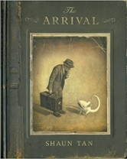  The Arrival  Shaun Tan | 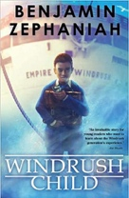  Windrush Child  Benjamin Zephaniah | 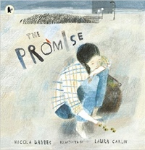  The Promise  Nicola Davies | 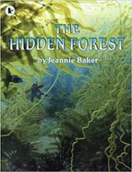  OR The Hidden Forest  Jeannie Baker
Length | 17 sessions, 3+ weeks | 15 sessions, 3 weeks | 15 sessions, 3 weeks | 16 sessions, 3+ weeks
Outcomes | Extended own version narratives  Letters, lists of rules, character descriptions, diaries, short playscripts, short reports, guides | Persuasive pitch to the local council  Thought bubble, informal letter, poem, diary entry, advice, informal letter | Narrative poem sequels  Promises, extended thought bubbles, diary entries, letters in role, figurative captions, summary poems | Balanced discussions  Research notes, non-chronological reports in the form of a letter to a character
Literary Leaf Text | 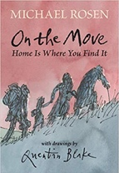  On the Move: Poems about Migration\  Michael Rosen |  | 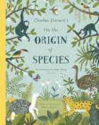  On the Origin of Species  Sabina Radeva
Length | 15 sessions, 3 weeks |  | 12 sessions, 2+ weeks
Theme/Term | Protest & activism Spring 1 |  | Utopia vs. dystopia Spring 2
Writing Root /  Spelling Seed Text | 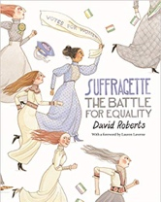  Suffragette: The Battle for Equality  David Roberts |   Romeo and Juliet  William Shakespeare | 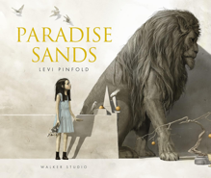  Paradise Sands  Levi Pinfold |   The Three Little Pigs Project  The Guardian
Length | 10 sessions, 2 weeks | 15 sessions, 3 weeks | 15 sessions, 3 weeks | 15 sessions, 3 weeks
Outcomes | Persuasive campaigns  Formal letters, diaries, balanced arguments, speeches, short news reports |  | Narrative prequel Descriptive story openings, informal notes of advice, formal letters in role, descriptive retellings, conversations between characters, book reviews | Collection of letters Headlines, news reports, persuasive speeches, narrative from a particular point of view, newspaper comments, diaries, debate
Literary Leaf Text | 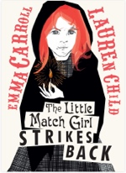  The Little Match Girl Strikes Back  Emma Carroll |  |   Caged Bird  Maya Angelou
Length | 15 sessions, 3 weeks |  | 10 sessions, 2 weeks
Theme/Term | Fate vs. free will Summer 1 |  | Crossing borders Summer 2
Writing Root /  Spelling Seed Text | 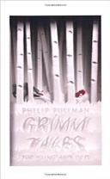  Grimm Tales for Young and Old  Phillip Pullman | 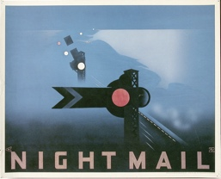  OR Night Mail  W H Auden | 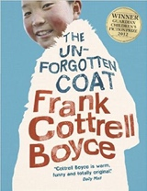  The Unforgotten Coat  Frank Cottrell Boyce
Length | 15 sessions, 3 weeks | 15+ sessions,3+weeks | 15+ sessions,3+weeks
Outcomes | Own version traditional tales  Retellings, character studies, monologues | Balanced argument  Diaries, letters, character descriptions, balanced arguments | Own version narratives  Diaries, explanations (sci experiment), dialogue, non-chronological reports | Poetry  Letters, diaries, information leaflets, instructions
Literary Leaf Text | Grimm Tales for Young and Old  Phillip Pullman |  | 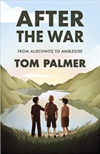  After the War: From Auschwitz to Ambleside  Tom Palmer
Length | 15 sessions, 3 weeks |  | 15 sessions, 3 weeks

