Pupil premium strategy statement

This statement details our school’s use of pupil premium (and recovery premium for the 2024 to 2025 academic year funding to help improve the attainment of our disadvantaged pupils.

It outlines our pupil premium strategy, how we intend to spend the funding in this academic year and the effect that last year’s spending of pupil premium had within our school.

School overview
Detail | Data
School name | Ellesmere Port Christ Church C of E Primary School
Number of pupils in school | 197
Proportion (%) of pupil premium eligible pupils | 24%
Academic year/years that our current pupil premium strategy plan covers (3-year plans are recommended) | 2024-2027
Date this statement was published | December 2025
Date on which it will be reviewed | July 2025
Statement authorised by
Pupil premium lead | Amanda Lancelott
Governor / Trustee lead | Danielle Sayers
Funding overview
Detail | Amount
Pupil premium funding allocation this academic year | £75330
Pupil premium funding carried forward from previous years (enter £0 if not applicable) | £0
Total budget for this academic year  If your school is an academy in a trust that pools this funding, state the amount available to your school this academic year | £75330

Part A: Pupil premium strategy plan

Statement of intent
Our philosophy
We believe in maximising the use of the pupil premium grant (PPG) by utilising a long-term strategy aligned to the SDP. This enables us to implement a blend of short, medium and long-term interventions, and align pupil premium use with wider school improvements and improving readiness to learn.
Overcoming barriers to learning is at the heart of our PPG use. We understand that needs and costs will differ depending on the barriers to learning being addressed. As such, we do not automatically allocate personal budgets per pupil in receipt of the PPG. Instead, we identify the barrier to be addressed and the interventions required, whether in small groups, large groups, the whole school or as individuals, and allocate a budget accordingly.
Our priorities
Setting priorities is key to maximising the use of the PPG. Our priorities are as follows:
- Ensuring quality first teaching in all classes
- Closing the attainment gap between disadvantaged pupils and their peers
- Ensuring that attainment at the end of KS2 at least achieves their own projected target
- Providing targeted academic support for pupils who are not making the expected progress
- Where disadvantaged pupils have SEND needs, their provision will be carefully considered
- Attendance of disadvantaged pupils is above 93.37%
- Addressing non-academic barriers to attainment such as attendance and behaviour
- Ensuring that the PPG reaches the pupils who need it most
We have taken time to consider strategies that have research-based evidence, but also strategies that have been tried and tested.

Challenges

This details the key challenges to achievement that we have identified among our disadvantaged pupils.
Challenge number | Detail of challenge
1 | If the curriculum is not carefully planned and sequenced, pupils may develop gaps in their learning
2 | If pupils have poor Maths and English skills, they may not be able to access and engage lessons within school
3 | Barriers to learning may be linked to SEND
4 | If a pupil is not displaying ready to learn behaviour, they may not engage and learn appropriately.
5 | Pupils with specific early life experiences may have difficulty accessing learning
6 | Pupils may not have attended wider school opportunities that build upon their cultural capital and develop a greater understanding of subject areas
7 | Pupils may not have a language rich home environment
8 | Attendance is below average for disadvantaged children and we recognise the need for constant support in this area
9 | Pupils may have lower levels of self-confidence and resilience

Intended outcomes
This explains the outcomes we are aiming for by the end of our current strategy plan, and how we will measure whether they have been achieved.
Intended outcome | Success criteria
For disadvantaged learners to become more secure in reading, writing and maths | For the gap to be lessened between children in receipt of the grant and their peers
For 75% of Year 1 children to pass the Phonics Screening check | For children to have a secure foundation of reading skills
For children to display effective behaviour for learning | Within lessons and around school pupils will demonstrate our school rules of “ready, respectful and safe”. There will be a reduced number of incidents of heightened behaviours logged on CPoms.
For children to be provided with a wealth of extra-curricular activities in order to develop their life experiences, communication skills, resilience and drive | Improved well-being and resilience for pupils will be evaluated using: pupil voice, staff voice and behaviour logs.
For attendance of disadvantaged learners to be above 95 % | This will be evidenced through attendance logs

Activity in this academic year
This details how we intend to spend our pupil premium (and recovery premium funding) this academic year to address the challenges listed above.

Teaching
Budgeted cost: £4610
Activity | Evidence that supports this approach | Challenge number(s) addressed
Grammarsaurus |  | 1 & 2
Phonics online (access to phonics programme) |  | 1 & 2
Purple Mash (used for homework as well) |  | 2, 6 & 7
White Rose (mastery for learning) |  | 1 & 2
First for Maths Academy (mastery for learning) |  | 1 & 2
Nessy (targeted intervention 1:1) |  | 5, 9 & 1

Targeted academic support – structured interventions, small group phonics teaching
Budgeted cost: £71188
Activity | Evidence that supports this approach | Challenge number(s) addressed
TA small group structured interventions to support English and maths |  | 1, 2, 3 & 7
TA small group structured emotional support |  | 1, 2, 3 & 7
Focussed phonics groups, reduced in size led by a TA |  | 1, 2, 3 & 7
Focused spelling intervention |  | 1, 2, 3 & 7

Wider strategies (for example, related to attendance, behaviour, wellbeing)
Budgeted cost: £19,807
Activity | Evidence that supports this approach | Challenge number(s) addressed
Attendance and punctuality monitoring- involving certificates, letters home to parents | Attendance for children in receipt of the PPG was 93.37% compared to their peers which was 98% | 4, 5 & 6
Emotional Literacy Support for identified children |  | 4, 5 & 6
Extra-curricular sports clubs |  | 5, 6 & 9
Resilience and behaviour regulation sessions (Commando Joe) |  | 4 & 9

Total budgeted cost: £95,605

Part B: Review of outcomes in the previous academic year

Pupil premium strategy outcomes
This details the impact that our pupil premium activity had on pupils in the 2024 to 2025 academic year.
90% of Year 1 children passed their phonics screening check
47 / 197 – 24% of children who attend Christ Church are Pupil Premium (PP)
12 / 47 – 26% of our PP children have learning mentor support
15 / 47 – 32% of our PP children are on the SEND register / list
10 / 47 – 21% of our PP children are ARE / ARE+
22 / 47 – 47% of our PP children are currently having some form of intervention. 9 / 22 – 41% of these children are having more than one intervention

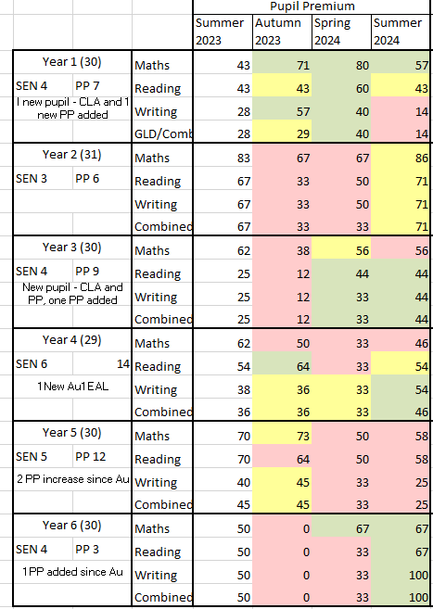

Within lots of classes the numbers have fluctuated throughout the year. Children have enjoyed residential visits such as Burwardsley, Delamere and York. There have been a variety of after school clubs from sporting clubs, times tables and arts and crafts. There has been a change of spelling programme mid year which has been viewed positively from staff and pupil voice.l

Externally provided programmes
Please include the names of any non-DfE programmes that you purchased in the previous academic year. This will help the Department for Education identify which ones are popular in England
Programme | Provider
Mastering Number | NCETM
Pathways to Spell | The Literacy Company

Service pupil premium funding (optional)
For schools that receive this funding, you may wish to provide the following information:
Measure | Details
How did you spend your service pupil premium allocation last academic year? | ELSA support where necessary
What was the impact of that spending on service pupil premium eligible pupils?

Further information (optional)
Use this space to provide any further information about your pupil premium strategy. For example, about your strategy planning, or other activity that you are implementing to support disadvantaged pupils, that is not dependent on pupil premium or recovery premium funding.

