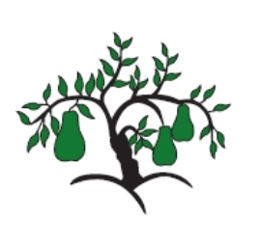 | Little Wandle - Letters and Sounds  EYFS Phonics Home Learning | 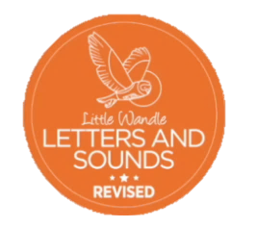
 | Phase 2 – Autumn 2 Week 4
Please support your child to practise and reinforce the phonemes and graphemes we are learning in school. More information and support can be found on the Little Wandle website - https://www.littlewandlelettersandsounds.org.uk/resources/for-parents/
Phonemes we will be focusing on this week in school –
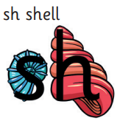  Share the shells. | 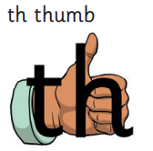  Thumbs up, we’re having fun. | 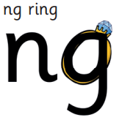  Bling on a ring. | 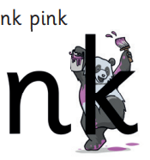  I think I am pink.

We will be reading and writing these words. Can you spot this week’s phonemes?
shell this ring pink shop thing thud fish wink moth wing sink

We will be reading short phases. Can you spot any tricky words? Can you segment and blend the words and look out for this week’s phonemes?
Can a moth quack? He has pink shells.

Can a pink moth buzz? His chick has pink wings.

We will be practising tricky words. Can you spot the tricky part of the word?

go no to into she push he of

