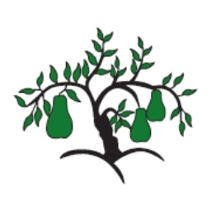 | Little Wandle - Letters and Sounds  EYFS Phonics Home Learning | 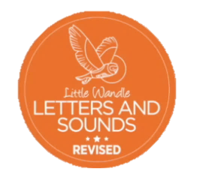
 | Phase 2 – Autumn 2 Week 1
Please support your child to practise and reinforce the phonemes and graphemes we are learning in school. More information and support can be found on the Little Wandle website - https://www.littlewandlelettersandsounds.org.uk/resources/for-parents/
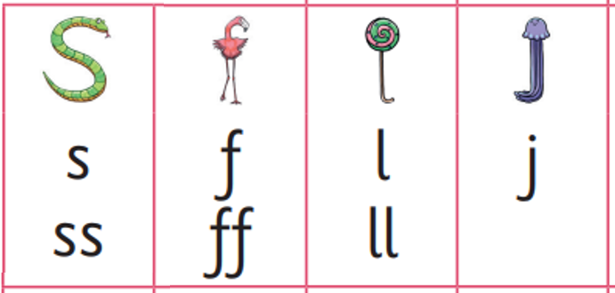
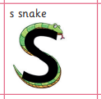
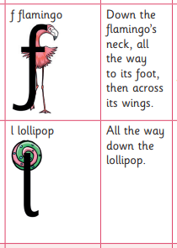
Phonemes we will be focusing on this week in school –
ss
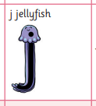

We will be reading these words. Can you spot this week’s phonemes?
huff off puff bell hill tell

mess hiss fuss jug jam jet

We will be reading short phases. Can you spot any tricky words? Can you find this week’s phonemes?
the jam on a hen pull on a red sock

put a bell in the the big cat is full

We will be practising tricky words. Can you spot the tricky part of the word?

I the is put pull full

