 | Little Wandle - Letters and Sounds  EYFS Phonics Home Learning | 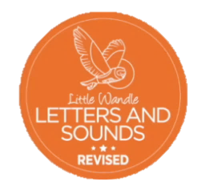
 | Phase 2 – Autumn 1 Week 4
Please support your child to practise and reinforce the phonemes and graphemes we are learning in school. More information and support can be found on the Little Wandle website - https://www.littlewandlelettersandsounds.org.uk/resources/for-parents/
Phonemes we will be focusing on this week in school –
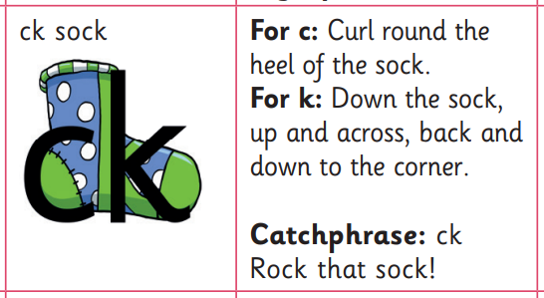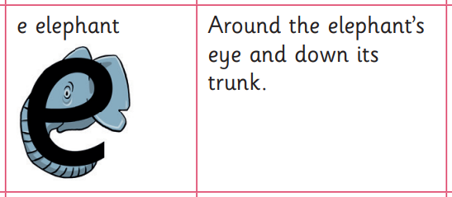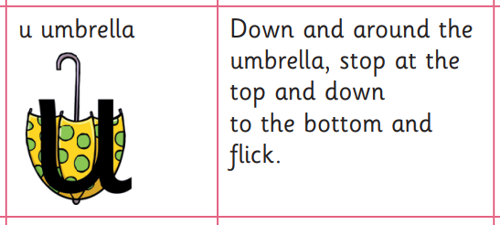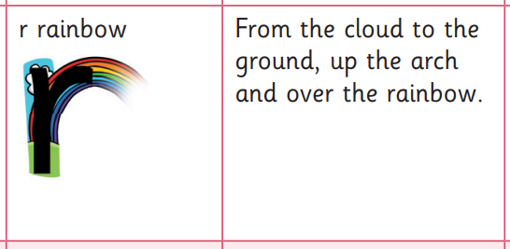

We will be learning to recognise and pronounce these phonemes especially after learning our first digraph (two letters one sound)

We will be reading and writing words. Can you spot this week’s phonemes?

mum duck pet pick

set red sock run

Can you write the initial sound for these pictures?

