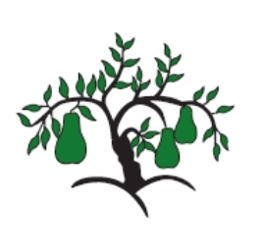 | Little Wandle - Letters and Sounds  EYFS Phonics Home Learning | 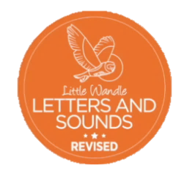
 | Phase 2 – Autumn 1 Week 3
Please support your child to practise and reinforce the phonemes and graphemes we are learning in school. More information and support can be found on the Little Wandle website - https://www.littlewandlelettersandsounds.org.uk/resources/for-parents/
Phonemes we will be focusing on this week in school –
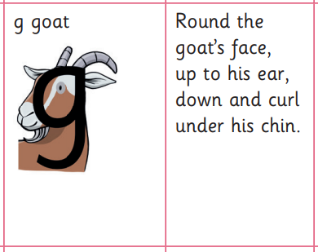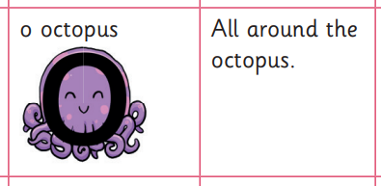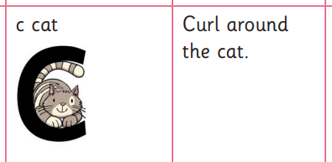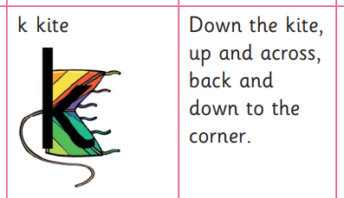

We will be learning to recognise these graphemes within words.

We will be reading and writing words. Can you spot this week’s phonemes?

man tap dog kit

cap dig kid cog

Can you write/tell your adult the initial sound for these pictures?
