 | Little Wandle - Letters and Sounds  EYFS Phonics Home Learning | 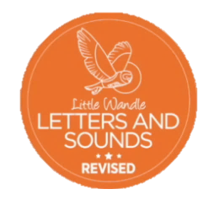
 | Phase 2 – Autumn 1 Week 1
Please support your child to practise and reinforce the phonemes and graphemes we are learning in school. More information and support can be found on the Little Wandle website - https://www.littlewandlelettersandsounds.org.uk/resources/for-parents/
Phonemes we will be focusing on this week in school –

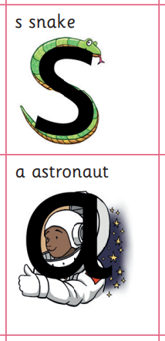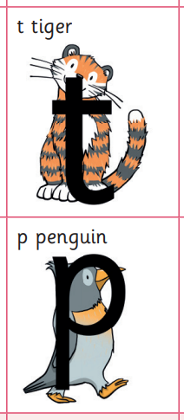

We will be learning to recognise and write the letters using the rhymes.
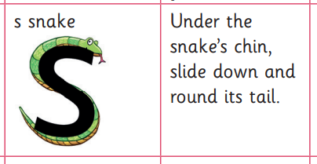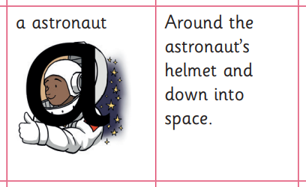

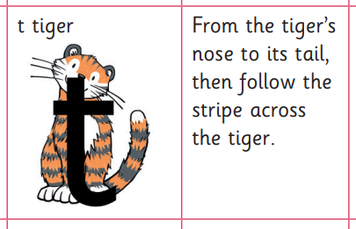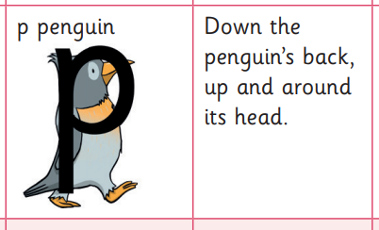

Can you match the initial sound to these pictures?

- 