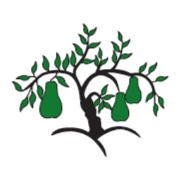 | Little Wandle - Letters and Sounds  EYFS Phonics Home Learning | 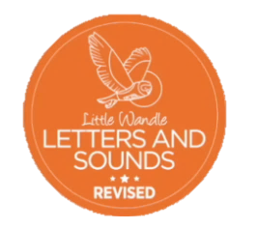
Phase 4 – Summer 2 Week 5
Focus – words ending in -er and -est
Please support your child to practise and reinforce the phonemes and graphemes we are learning in school. More information and support can be found on the Little Wandle website - https://www.littlewandlelettersandsounds.org.uk/resources/for-parents/

We will be reading words ending in -er and -est.
brighter sleeper painter trainer boaster sweeter greenest smartest
sweetest clearest brownest brightest

We will be practising tricky words. Can you spot the tricky part of the word?
to into all are they one out today

Can you add -er and est to these words, then read the new word you have made?
word |   strong | 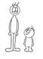  small |   cold
+er
+est

We will be reading sentences. Can you spot any tricky words?
Today they went out and picked the sweetest and plumpest carrots.
It was the brightest star, brighter of all of the stars and the clearest one.

