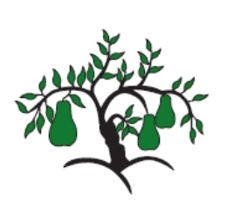 | Little Wandle - Letters and Sounds  EYFS Phonics Home Learning | 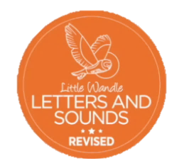
Phase 4 – Summer 2 Week 2
Focus – CCVC, CCCVC, CCV and CCVCC words
Please support your child to practise and reinforce the phonemes and graphemes we are learning in school. More information and support can be found on the Little Wandle website - https://www.littlewandlelettersandsounds.org.uk/resources/for-parents/

We will be reading CCVC, CCCVC, CCV and CCVCC words
sweet sleep slight croak crown clown
street screech sprain strain screen
stair smear star clear tree free
three spear spoilt fright scoop spoil

We will be practising tricky words. Can you spot the tricky part of the word?
are pure sure here little says
was do were

Can you match the words and pictures?

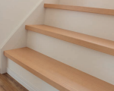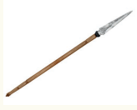

stars stair spear street
We will be reading sentences. Can you spot any tricky words?
The little crown had a star on top.
The kite got struck in the tree when the storm was bad.
The three frogs are croaking at the clown in the street.

