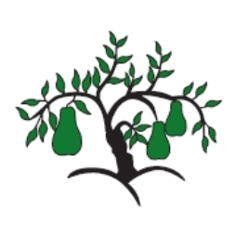 | Little Wandle - Letters and Sounds  EYFS Phonics Home Learning | 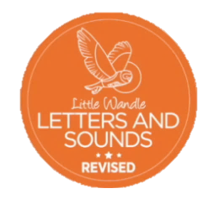
 | Phase 2 – Autumn 2 Week 2
Please support your child to practise and reinforce the phonemes and graphemes we are learning in school. More information and support can be found on the Little Wandle website - https://www.littlewandlelettersandsounds.org.uk/resources/for-parents/
Phonemes we will be focusing on this week in school –
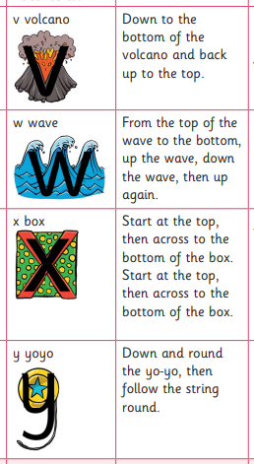
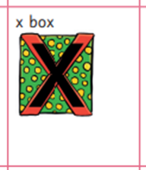

We will be reading these words. Can you spot this week’s phonemes?
yes vet wet fix van wax
yum six wig yap fox

We will be reading short phases. Can you spot any tricky words? Can you find this week’s phonemes?
a red sock in a van a big dog at the vet

a nap in a box

We will be practising tricky words. Can you spot the tricky part of the word?

his her has the put pull full and

