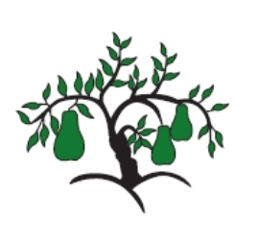 | Little Wandle - Letters and Sounds  EYFS Phonics Home Learning | 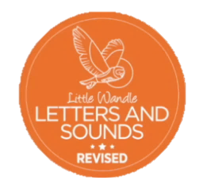
Phase 4 – Summer 2 Week 3
Focus – words ending in s, es and longer words
Please support your child to practise and reinforce the phonemes and graphemes we are learning in school. More information and support can be found on the Little Wandle website - https://www.littlewandlelettersandsounds.org.uk/resources/for-parents/

We will be reading words ending in s, es and longer words. Can you spot the different sound the s at the end makes? (/s/, /z/)
sports boasts paints floats starts streets
crowds groans trains storms spoons spears
dresses screeches splashes speeches
balloon appear portrait person perfect

We will be practising tricky words. Can you spot the tricky part of the word?
put pull full push my by like some come love do

Can you match the words and pictures?
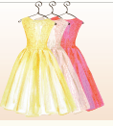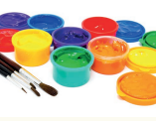

dresses balloon trains paints
We will be reading sentences. Can you spot any tricky words?
The balloon floats and twist in the air as the wind blows it.
I love to see the trains pushing and pulling the coaches.
My dress scrunches up when I sit down.

