 | Little Wandle - Letters and Sounds  EYFS Phonics Home Learning | 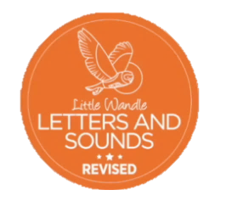
Phase 4 – Summer 1 Week 5
Focus – words ending -ing, -ed, -est
Please support your child to practise and reinforce the phonemes and graphemes we are learning in school. More information and support can be found on the Little Wandle website - https://www.littlewandlelettersandsounds.org.uk/resources/for-parents/

We will be reading words ending -ing, -ed, -est .Can you spot the different sounds for -ed?
swimming(swimm/ing) bumping(bump/ing) snapping(snapp/ing) bumped helped jumped cracked grunted shifted hunted printed
plumpest(plump/est) softest(soft/est) strongest(strong/est)

We will be practising tricky words. Can you spot the tricky part of the word?
out today

Can you match the words and pictures?

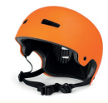

helmet forest blossom jumping

We will be reading sentences. Can you spot any tricky words?
Today we are going swimming in the pool.
He jumped up out of bed and bumped his legs when his foot got twisted in the blanket.

