 | Little Wandle - Letters and Sounds  EYFS Phonics Home Learning | 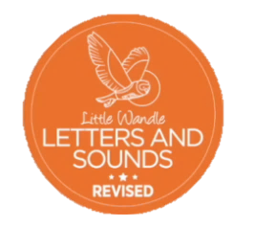
Phase 3 – Spring 2 Week 4
Focus – longer words / words ending in -ing / compound words
Please support your child to practise and reinforce the phonemes and graphemes we are learning in school. More information and support can be found on the Little Wandle website - https://www.littlewandlelettersandsounds.org.uk/resources/for-parents/
Phonemes we will be focusing on this week in school –
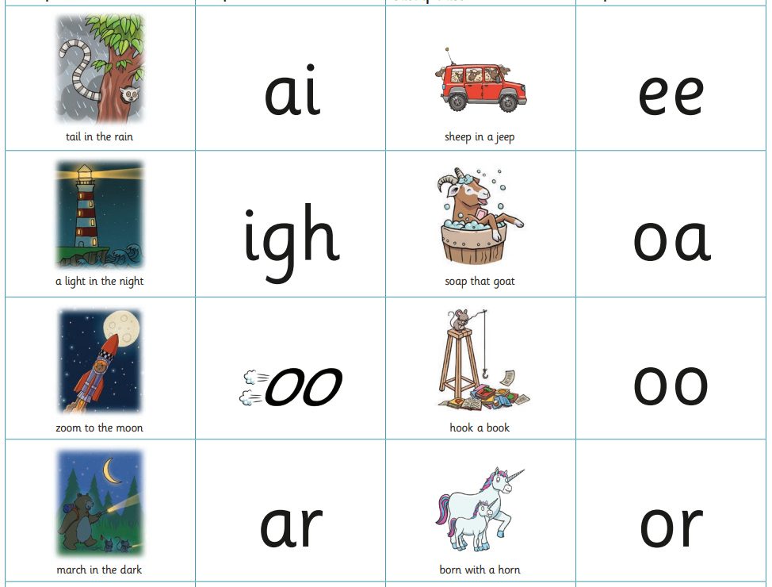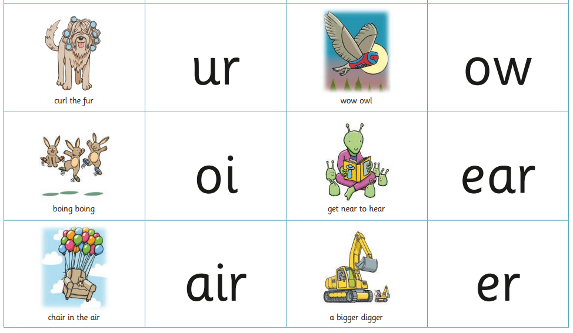

We will be reading and writing longer words. Can you spot this weeks phonemes?
market wooden finger river looking waiting zooming marching
singing fighting winking farming
farmyard popcorn carpark rooftop

We will be reading sentences. Can you spot any tricky words?
We are up at night looking at the moon.
It is fun chatting and singing on the rooftop garden.

We will be practising tricky words. Can you spot the tricky part of the word?
he we me be was you they all

