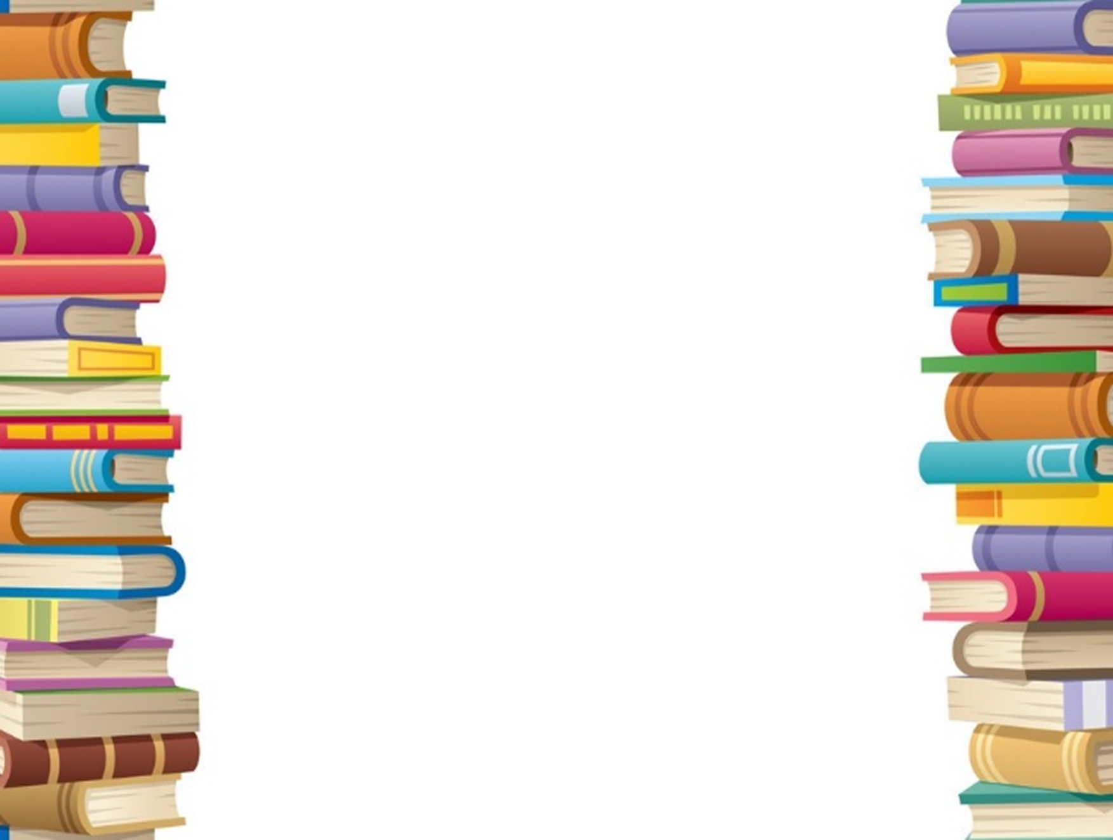

**Bill’s New Frock – Anne Fine**

**Charlotte’s Web – EB White**

**Why the Whales Came – Michael Morpurgo**

**The Firework Maker’s Daughter – Phillip Pullman**

**The Snow Walker’s Son – Catherine Fisher**

**Perry Angel’s Suitcase – Glenda Millard**

**Voices in the Park – Anthony Browne**

**Richard III - Shakespeare**

**As you Like it —Shakespeare**

**The Tempest —Shakespeare**

**Othello—Shakespeare**

**Danny the champion of the world—Roald Dahl**

**The Last Wolf—Michael Morpurgo**

**Picnic on the moon poems—Brian Morse**

**Dear Olly—Michael Morpurgo**

**Dominic’s Discovery—Gervaise Phinn**

**Ask Uncle Albert—Russell Stannard**

**Journey to the River Sea—E Ibbotson**

**Or**