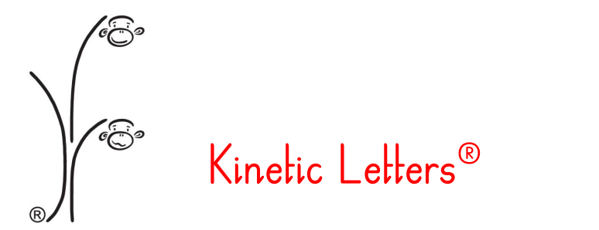

At Tarporley Primary we use a very comprehensive handwriting structure to teach letter formation and to create the best learning environment for fluent handwriting- from EYFS to year 6.

In Hedgehogs we will be learning the various body positions to strengthen our core: bear, meerkat, penguin, stone lion and lizard.

We will spend a lot of time in the first half term learning how to pick up a pencil/pen, hold a pencil/pen and doing hand and finger exercises to strengthen key body parts ready for learning accurate letter formation and flow.

The programme uses great visuals and rhymes to help remember how and where to start each letter. You will soon learn about Curly and his tree (3 by the tree!), and his friends, the brave and scared monkeys. One thing to always remember is that NO letters or numbers start on the ground!

We love this programme and our Reception children’s handwriting is always widely praised whenever we have visitors. We believe excellence in handwriting formation means you are on the way to being an excellent writer.

