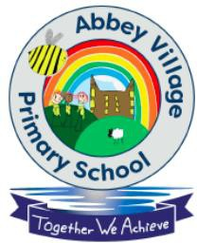

Abbey Village Primary School
Holiday List 2026/2027

Autumn Term 2026 (74 days)
Tuesday 1st September 2026 | Training Day (1)
Wednesday 2nd September 2026 | School opens 8:45am
Friday 23rd October 2026 | School closes 3:20pm Half term
26th-30th October 2026 | Half Term Holiday
Monday 2nd November 2026 | School opens 8:45am
Friday 18th December 2026 | School closes 2:20pm Christmas holiday
21st December – 1st January | Christmas Holiday Break

Spring Term 2027 (54 Days)
Monday 4th January 2027 | Training Day (2)
Tuesday 5th January 2027 | School opens 8:45am
Friday 12th February 2027 | School closes 3:20pm Half term
15th – 19th February 2027 | Half Term Holiday
Monday 22nd February 2027 | School opens 8:45am
Thursday 25th March 2027 | School closes 2:20pm Easter holiday
26th March to 9th April 2027 | Easter Holiday Break

Summer Term 2027 (67 Days)
Monday 12th April 2027 | Training Day (3)
Tuesday 13th April 2027 | School Re-opens at 8:45am
Monday 3rd May 2027 | Bank Holiday
Friday 28th May 2027 | School closes 3:20pm Half term
31st May to 4th June 2027 | Half Term Holiday
Monday 7th June 2027 | Training Day (4)
Tuesday 8th June 2027 | Training Day (5)
Wednesday 9th June 2027 | School Re-opens at 8:45am
Wednesday 21st July 2027 | School closes 2:20pm Summer holiday
Total Number of Pupil Openings 190 | Total Number of School Openings 195

