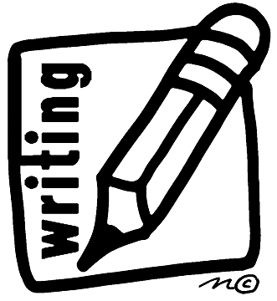
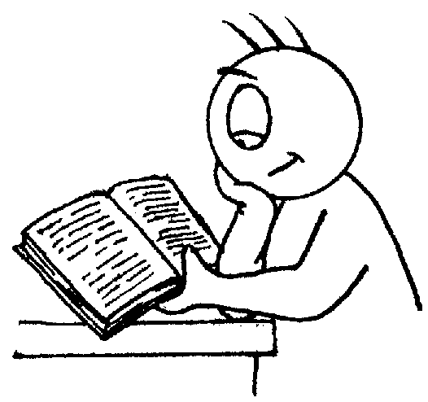
Writing

- Write simple sentences which can be read by themselves & others.
- Write name (correct upper & lower case).
- Use capital letters and full stops to demarcate sentences.
- Write clearly demarcated sentences.
- Correct pencil grip.
- Correct letter formation for familiar words.
- Use their phonic knowledge to write the sounds they hear in words.
- Can write their tricky words, e.g. like, was, said etc.
Reading

- Read some common irregular words.
- Identify rhymes and alliteration.
- Join in with rhyming patterns.
- Read & understand simple sentences.
- Demonstrate understanding when talking with others about what they have read.
- Make basic predictions.
- Identify start & end of a sentence.
- Use phonic knowledge to blend regular words, e.g. s – a – t, sat.


Number Facts
Don’t forget to practise your number bonds and times tables regularly where appropriate – these will help you meet your end of year expectations
Mathematics

- Count reliably to 20.
- Order numbers 1 – 20.
- Say 1 more/1 less to 20.
- Add & subtract two single digit numbers using quantities and objects.
- Count on or back to add & subtract two single digit numbers.
- Solve problems including doubling, halving and sharing.
- Use mathematical language to compare quantities and objects, e.g. taller, shorter, heavier, lighter, bigger, smaller, o’clock etc.
- Recognise, create and describe patterns.

Budbrooke
Primary School
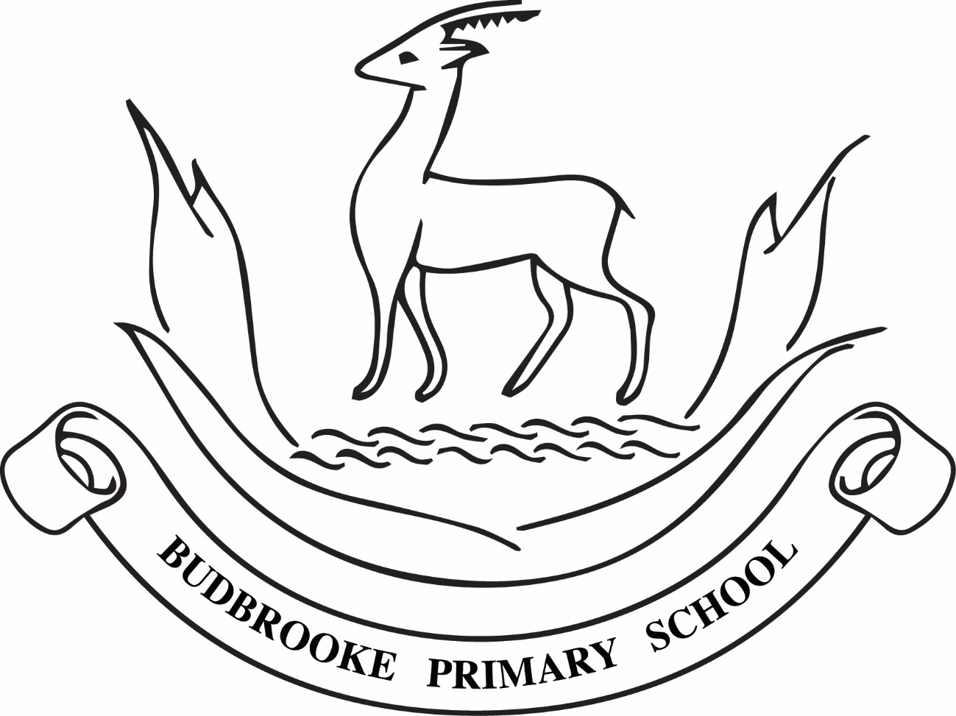
End of Year Expectations
for Reception

This booklet provides information for parents and carers on the end of year expectations for children in our school. The staff have identified these expectations as being the minimum requirements your child must meet in order to ensure continued progress throughout the following year.

All the objectives will be worked on throughout the year and will be the focus of direct teaching. Any extra support you can provide in helping your children to achieve these is greatly valued.

If you have any queries regarding the content of this booklet or want support in knowing how best to help your child please talk to your child’s teacher.

Visit our website at https://www.budbrooke.warwickshire.sch.uk/ for more information

